Half-term Homework: this is a two week project and due in Tuesday, 7th November
Over the half term we would like to give you a choice of homework. Please choose one of the activities below or feel free to be creative and come up with your own brilliant Stone Age idea. We are very excited to see what you will choose.
Take a trip…  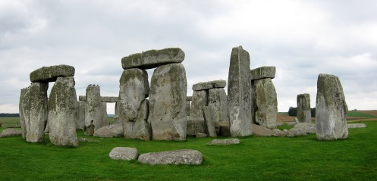  visit Stonehenge and take photographs to create a photo diary | 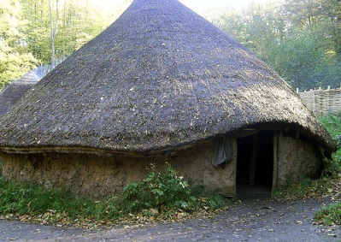  Stone Age roundhouse  Make a model - be creative | 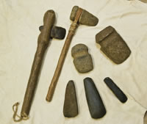  Stone Age Tools  Make a Stone Age tool | Stone Age jewellery  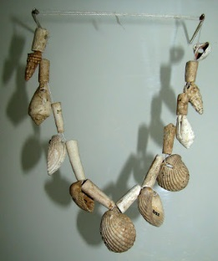  What could you use to make some jewellery? | Information poster:  Research and present information about either Stonehenge or a Stone Age roundhouse

