Half-term Homework: this is a two week project and due in 30th October. 2018
For the next two weeks and over the half term we would like to give you a choice of homework. Please choose one of the activities below or feel free to be creative and come up with your own brilliant Stone Age idea. We are very excited to see what you will choose.
Take a trip…  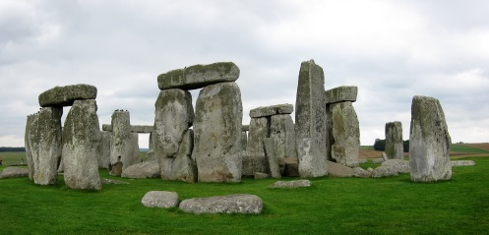  visit Stonehenge and take photographs to create a photo diary | 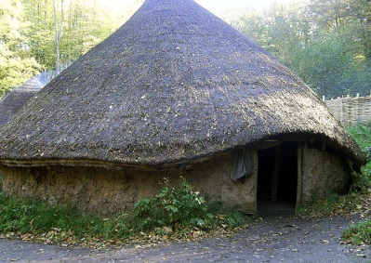  Stone Age roundhouse  Make a model - be creative | 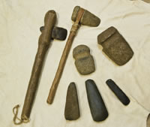  Stone Age Tools  Make a Stone Age tool | Stone Age jewellery  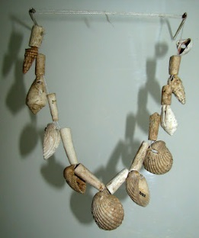  What could you use to make some jewellery? | Information poster:  Research and present information about either Stonehenge or a Stone Age roundhouse

We will be opening a Stone Age Museum on Thursday 1st November at 9.00am-9.30am in the school hall. This will be an opportunity for children to share with parents and friends their home learning.

