Dear Parents and Carers

This term our Heartsmart focus has been ‘Too Much Selfie Isn’t Healthy’. As part of this focus, each year group has been asked to think of an act of service for the community. In Year 4 we thought it would be great to support the Food Bank. As a result, we have decided to create a ‘reverse advent calendar’ during the month of December.
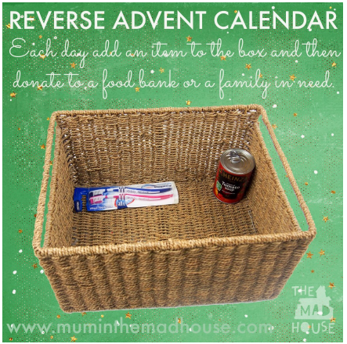

Each day during December we would welcome a donation towards the food bank. Every day we will ask for a different type of donation which will be outlined on the calendar below. We would love it if your child could bring in a donation for just one day, but are happy for them to bring in more than one donation if they wish. This is a voluntary act of service to support our learning around ‘Too Much Selfie Isn’t Healthy’. We will have a box outside the classroom to collect donations.

Monday 3rd | Tuesday 4th | Wednesday 5th | Thursday 6th | Friday 7th
Tinned Meat e.g. ham, mince, corned beef, chicken.  Please do not send in pies. | Tinned tomatoes or other tinned vegetables | Tinned spaghetti or ravioli | Cereals – hot or cold | Milk – powdered or UHT, not skimmed please
Monday 10th | Tuesday 11th | Wednesday 12th | Thursday 13th | Friday 14th
Fruit juice (UHT) | Oat biscuit, crackers, crisp breads | Cooking sauces | Puddings, rice pudding or custard | Instant Mash
Monday 17th | Tuesday 18th | Wednesday 19th | Thursday 20th | Friday 21st
Tinned fruit | Biscuits | Sweet and savoury spreads | Toiletries and small Christmas gift sets | Christmas crackers

Please do not send in any items that include alcohol as the food bank are not able to accept them.

Representatives from the Basingstoke Food Bank will be coming to collect our donations on the last day of term.
Thank you for your support

Mrs Tunnicliffe, Mrs Happy and Miss Hardy

