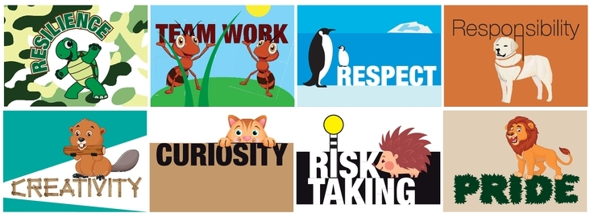I can learn spellings by writing them everyday

This week’s sound: ‘oi’ spoil the boy.

 | Day 1 | Day 2 | Day3 | Day 4 | Day 5
join
coin
soil
point
spoil

