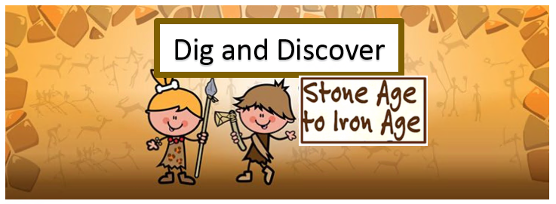

In **DT** we will be designing and making a biscuit Stonehenge. Children will have the opportunity to investigate which type of biscuit will be most suitable to recreate the historic site.

After researching cave **Art** children will use a range of materials to create their own version.

Children will be taking part in ‘Listen to Me’ **Music** lessons every week. In the Autumn term they will be playing brass instruments.

This term, Year 3 will explore the big question,

‘Is all change needed?’

**Dates for the diary …**Curriculum workshop – 24th September 8.30am – 10.00am   
School trip to Stonehenge – 4th OctoberEnd of topic event - 24th October at 2pm

Through our **English** we will be looking at features of stories. We will read Stone Age Boy as our focus text and will write our own character descriptions and settings based on this. Children will build up to writing their own version of the story and will have an opportunity to plan, draft and edit their work.

Using the book Stone Girl, Bone Girl we will complete some non-fiction pieces of writing including a fact file on Mary Anning and instructions.

Our **Computing** this term will involve using search engines, with a focus on safety, in order for the children to research cave art. Children will use their knowledge of copy and paste to import cave art images into a word document.

**PE** will take place twice every week. We will be creating Stone Age dances and our games lessons will be led by Planet Education. Please ensure your child has a named kit in school every day. Our PE days are Monday and Wednesday.

Our **History** this term will involve the children becoming ‘archaeologists’ and examining artefacts and photos to help them learn how people lived in prehistoric times.

In **Science** children will have the opportunity to investigate and observe rocks in order to group them based on their appearance and simple properties. Everyone will have the chance to make their own ‘fossil’ to help them understand how fossils are formed.

Our **RE** willinvolve reading the story of Rama and Sita and discussing how this demonstrates to Hindu’s about good and evil. We will continue to teach the **HeartSmart** principles through our class worships and everyday opportunities that arise.

**Maths** this term we will focus on place value. Children will build on their knowledge of tens and ones with the introduction of hundreds. Through the use of practical resources we will represent, compare and order numbers to 1000. Once we are secure in our place value knowledge we will move onto strategies used to solve addition and subtraction calculations including apparatus, number lines and the column method.