19.03.20
I can tell the time to quarter past and quarter to.
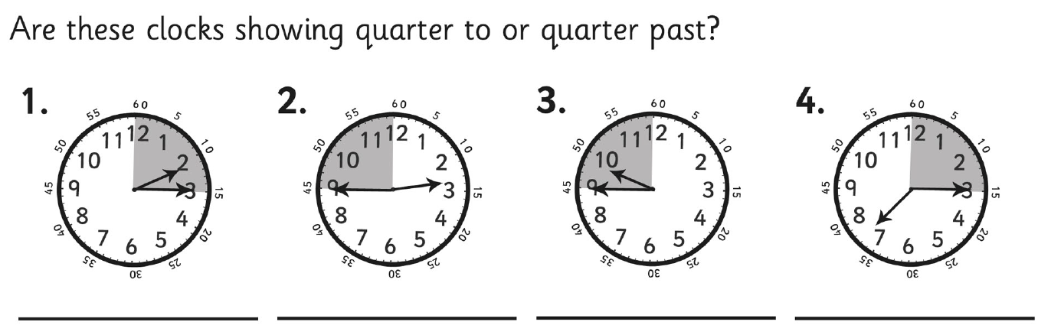

Match the clocks to the correct time.
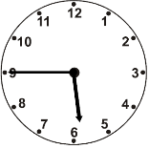 |  | Quarter to 7
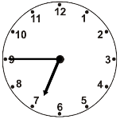 |  | Quarter past 8
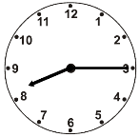 |  | Quarter to 6
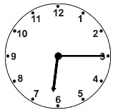 |  | Quarter past 6

Draw the hands on the clocks
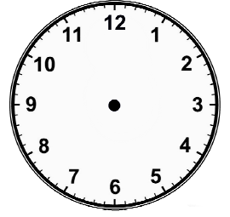  Quarter to 1 | Quarter past 1 | Quarter to 2
Quarter past 2 | Quarter to 3 | Quarter past 3

The minute hand is pointing to ___  The hour hand is just after____  The time is quarter ________ | 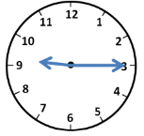 | The minute hand is pointing to the 3  The hour hand is just after the _____  The time is quarter past 1 | 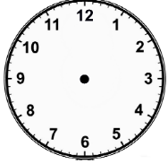
The minute hand is pointing to ___  The hour hand is just before ____  The time is quarter __________ | 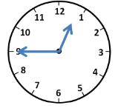 | The minute hand is pointing to the 9  The hour hand is just before the _____  The time is quarter to 8
The minute hand is pointing to ___  The hour hand is just after____  The time is quarter ________ | 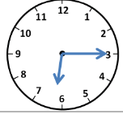 | The minute hand is pointing to the 3  The hour hand is just after the _____  The time is quarter past 11
The minute hand is pointing to ___  The hour hand is just before ____  The time is quarter __________ | 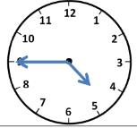 | The minute hand is pointing to the 9  The hour hand is just before the _____  The time is quarter to 3

___________________________________________________________________________________________________________________________________________________________________________________________________________________________________________________________________



