How many hours in a day? | ___ minutes
How many minutes in half an hour? | ___ minutes
How many minutes in quarter of an hour? | ___ minutes
24.03.20
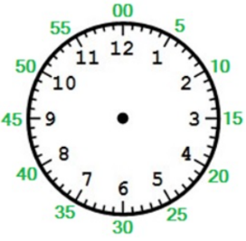
I can understand hours and days

How many minutes?
How many minutes in 1 hour? | ___ minutes
How many minutes in 1 hour 5 minutes? | ___ minutes
How many minutes in 1 hour and 10 minutes? | ___ minutes
How many minutes in 1 hour and 15 minutes?
How many minutes in 1 hour and 20 minutes?
How many minutes in 1 hour and 25 minutes?

How many hours and minutes?
90 minutes | ___ hours and ___ minutes
95 minutes | ___ hours and ___ minutes
100 minutes | ___ hours and ___ minutes
Convert the activity times to hours and minutes.
Football | 90 minutes | ___ hours and ___ minutes
Hockey | 75 minutes | ___ hours and ___ minutes
Rugby | 120 minutes
Netball | 65 minutes
Skating | 80 minutes
Cycling | 100 minutes




