Maths: Thursday 19th March 2020
I can count in steps of 10.
Practise counting in 10’s aloud to someone at home.
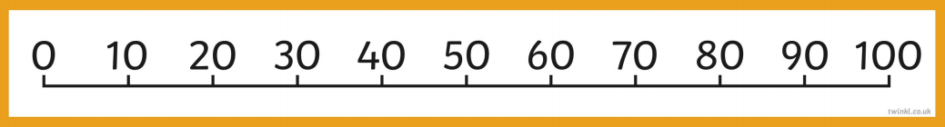
How many bowling pins are there? Count in 10’s.
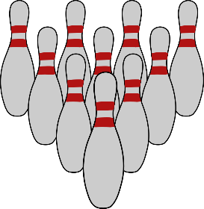
How many bowling pins are there? Count in 10’s.
How many bowling pins are there? Count in 10’s.
What does this represent? Count in 10’s:

What number does each row of numicon represent? Count in 10’s. You could write the numbers underneath to help like this:
010 20 30
0

0

0

Can you fill in the number tracks:
0 | 10 |  | 30 |  | 50

10 | 20 |  | 40

30 |  | 50 | 60

How many toes? Count in 10’s.
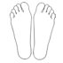
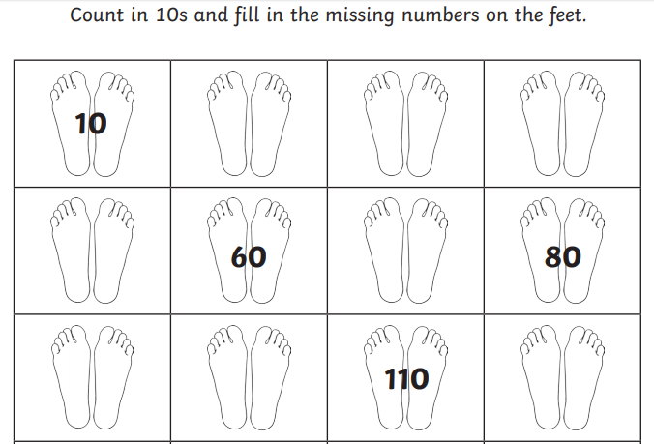
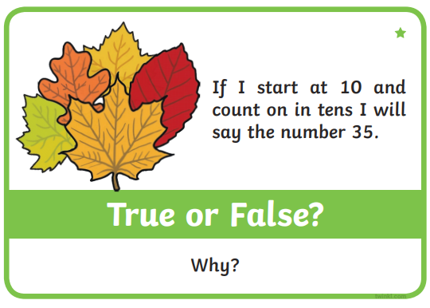
Challenge:

