**Maths: Tuesday 17th March 2020**

**I can count in steps of 2..**

**Practise counting in 2’s out loud to someone at home.** 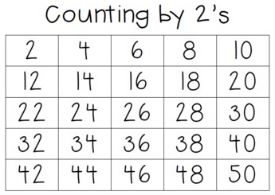

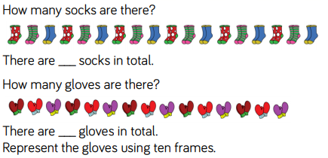



**Group the socks into 2’s to help you find out how many there are.**

|  |
| --- |
| **There are _______ socks in total.** |



|  |  |  |  |  |
| --- | --- | --- | --- | --- |
|  |  |  |  |  |
| **0** |  |  |  |  |



|  |  |  |  |  |  |  |  |  |  |  |
| --- | --- | --- | --- | --- | --- | --- | --- | --- | --- | --- |
| |  |  |  |  |  | | --- | --- | --- | --- | --- | |  |  |  |  |  | | **10** |  |  |  |  | |



|  |  |  |  |  |  |  |  |  |  |  |
| --- | --- | --- | --- | --- | --- | --- | --- | --- | --- | --- |
| |  |  |  |  |  | | --- | --- | --- | --- | --- | |  |  |  |  |  | | **14** |  |  |  |  | |



|  |  |  |  |  |  |  |  |  |  |  |
| --- | --- | --- | --- | --- | --- | --- | --- | --- | --- | --- |
| |  |  |  |  |  | | --- | --- | --- | --- | --- | |  |  |  |  |  | | **24** |  |  |  |  | |

|  |  |  |  |  |  |  |
| --- | --- | --- | --- | --- | --- | --- |
| **12** |  | **16** |  |  |  |  |

|  |  |  |  |  |  |  |
| --- | --- | --- | --- | --- | --- | --- |
|  |  | **24** |  |  |  | **32** |

|  |  |  |  |  |  |  |
| --- | --- | --- | --- | --- | --- | --- |
|  | **34** | **36** |  |  |  |  |

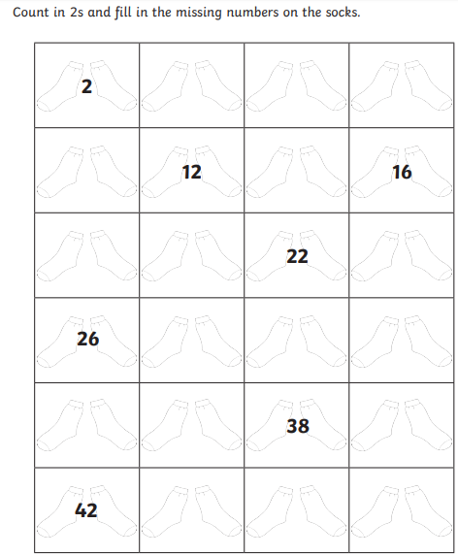

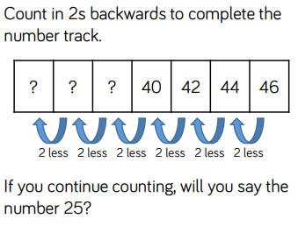***Challenge:***

**Extra if you would like:**

