Maths: Wednesday 18th March 2020
I can count in steps of 5.
Practise counting in 5’s out loud to someone at home. 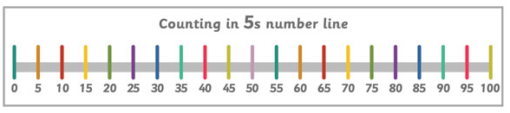
How many dots are there? Count in 5’s.
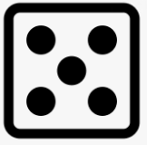
How many dots are there? Count in 5’s.
How many fingers are there? Count in 5’s.
Group the counters to help you find out how many there are.
There are _______ counters in total.

What number does each row of numicon represent? Count in 5’s. You could write the numbers underneath to help like this:
0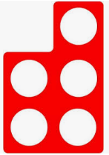51015

0

0

0
Can you fill in the number tracks:
0 | 5 |  | 15 |  | 25

15 | 20 |  | 30 |  | 40

10 |  | 20 | 25

25 |  |  | 40 | 45

Count in 5’s and fill in the missing numbers. You could colour them in afterwards!
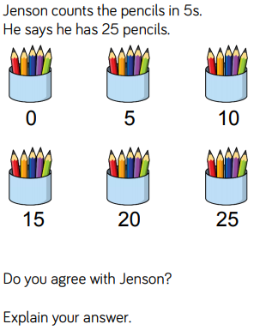
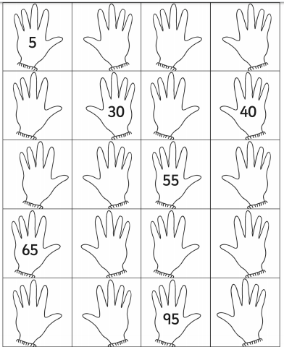
Challenge:

