I can draw a bar chart
This tally chart shows how children travelled to school. Complete a bar to represent the data. Use a scale of 2.
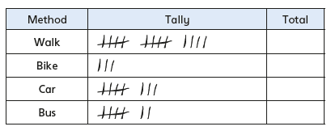

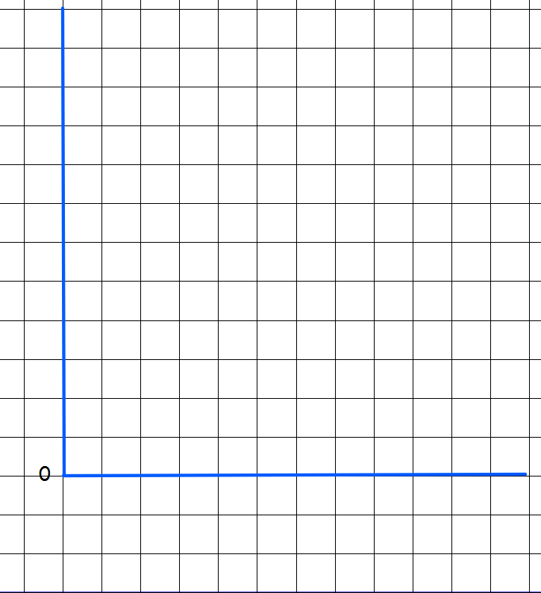
This table shows favourite pizza toppings. Complete a bar chart to represent this data. Choose an appropriate scale.
