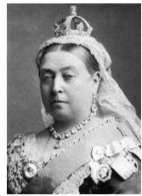

Thursday 19th March 2020

I can write a persuasive letter

