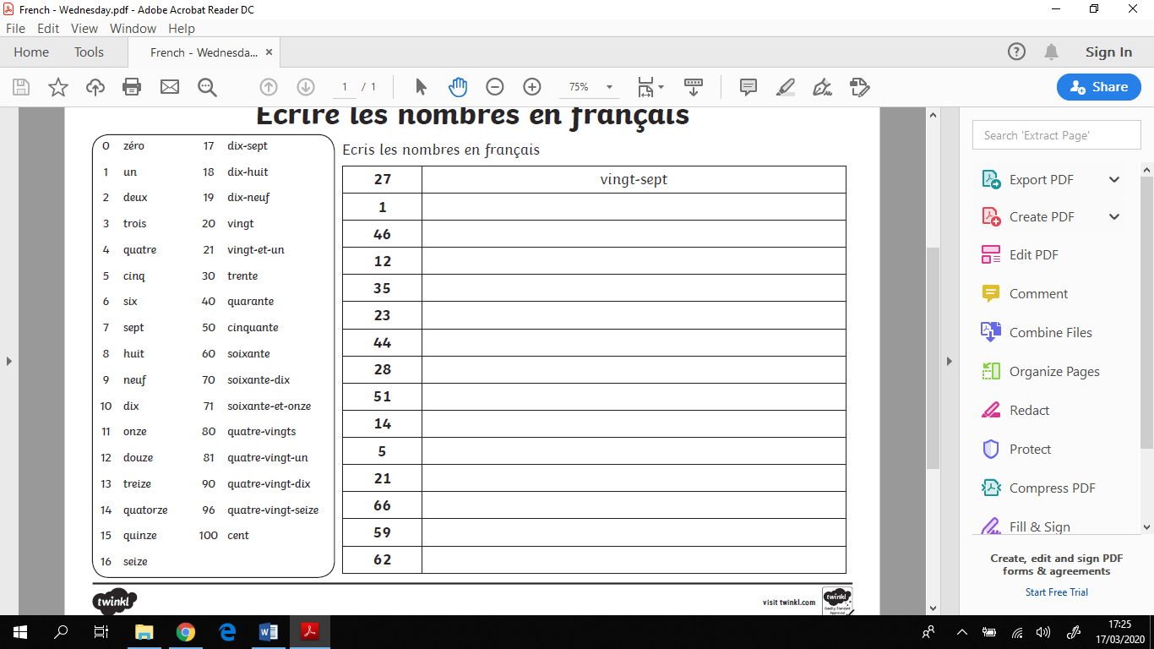

I can write numbers in French up to 100.

Write the numbers in French, using the hints in the box to the left.