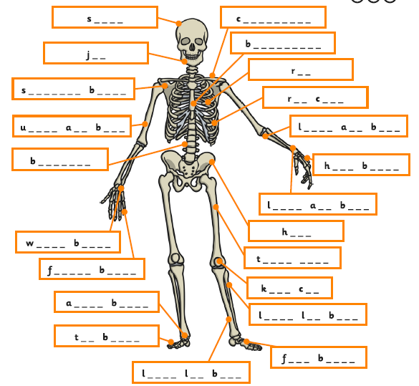

I can use scientific vocabulary to label the skeleton.