I can subtract 2 mixed numbers.
Part 1 – Use the bar models to calculate the problems.
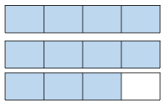
E.g 2$\frac{3}{4}$ – 1 $\frac{2}{8}$ = 1 $\frac{4}{8}$

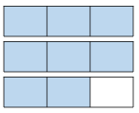
- 2$\frac{2}{3}$ – 1 $\frac{2}{6}$ =

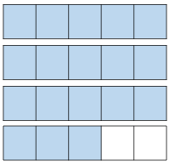
- 3$\frac{3}{5}$ – 1 $\frac{8}{10}$ =

- $4\frac{2}{5}$ – 2 $\frac{7}{10}$ =

I have coloured in the amount you have already.
Step 1 – Cross out the whole that you’re subtracting first
Step 2 – Change the denominators so that they are the same 2$\frac{3}{4}$ = 2$\frac{6}{8}$
Step 3 – Split the box into the new denominator
Step 4 – Then cross out the amount on the second fraction
Step 5 – The answer is what you are left with

Part 2 – Solve the calculations in your maths book.
Step 1 – Convert the fractions so they have the same denominator
Step 2 – Subtract the whole numbers
Step 3 – Subtract the fractions using the wholes if you need to
Step 4 – Put the whole and fractions together
$E.g. 3\frac{2}{5}$ – 1 $\frac{3}{10}$ = $3\frac{2}{5}= 3\frac{4}{10}$ 3-1 = 2 $\frac{4}{10}- \frac{3}{10}=\frac{1}{10} 2+ \frac{1}{10}=2\frac{1}{10}$
- $5\frac{3}{4}$ – 3 $\frac{8}{12}$
- $4\frac{1}{2}$ – 2 $\frac{5}{14}$ =
- $3\frac{6}{7}$ – 2 $\frac{7}{21}$ =
- $6\frac{4}{6}$ – 3 $\frac{6}{12}$ =
- $10\frac{8}{9}$ – 6 $\frac{2}{3}$ =
Part 3 - Complete the pyramid, subtracting the two numbers next to each other to find the number for the box below. Remember to start the calculation with whichever number is bigger
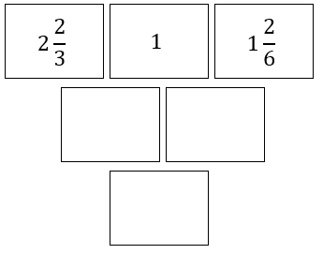

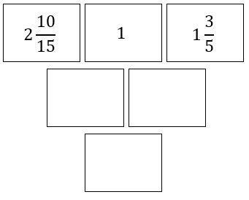

Challenges – Solve these problems using the subtraction method we have practised
- At a party, 3$\frac{3}{4}$ of the pizzas were eaten and 2$\frac{5}{8}$ of the cakes were eaten.
What is the difference in the amount of pizzas and cakes eaten?

- At a party, 4$\frac{3}{5}$ of the pizzas were eaten and 3$\frac{2}{3}$ of the cakes were eaten.
What is the difference in the amount of pizzas and cakes eaten?

- Jake walked 4$\frac{4}{5}$km. Toby walked 5$\frac{1}{3}$km. How much further did Toby walk?
How far did they walk all together?

- Ashley bought 7$\frac{4}{7}$m of wood. Rhys bought 3$\frac{2}{3}$m less than Ashley.
How much wood did Rhys buy?
How much did they have all together?

