I can multiply a unit fraction by an integer using repeated addition.
Part 1- Fill in the gaps in the table and fill in the number lines

Part 2 – Using the bar models and repeated addition, work out the calculations below.
Calculation | Repeated addition | Pictorial | Answer
5 x $\frac{1}{7}$ | $$\frac{1}{7}+\frac{1}{7}+\frac{1}{7}+\frac{1}{7}+\frac{1}{7}$$ | $\frac{5}{7}$ | $$\frac{5}{7}$$
4 x $\frac{1}{6}$ | $$\frac{1}{6}+\frac{1}{6}+\frac{1}{6}+\frac{1}{6}$$
$\frac{1}{11}$ x 6
 | $$\frac{1}{3}+\frac{1}{3}$$
 |  |  | $$\frac{7}{9}$$

Part 3 – Use repeated addition to solve these problems
- $\frac{1}{5}$ x 4 =
- $\frac{1}{3}$ x 2 =
- $\frac{1}{6}$x 4 =
- $\frac{1}{10}$x 10 =
- $\frac{1}{2}$ x 3 =
- $\frac{1}{5}$x 6 =

Part 4 – Answer these word problems using repeated addition
- Miss Thomas is having a pizza party. Each person gets $\frac{1}{5}$ of a pizza. There are 3 people at the party. How much of a pizza is eaten?

- Miss Fowler is having a birthday party. Each person gets $\frac{1}{6}$ of the cake. There are 5 people at the party. How much of a cake is eaten?

- Mrs Poole ran $\frac{1}{4}$ of a mile on Monday, Tuesday and Wednesday. How far did she run all together?

- Mrs Stone swam $\frac{1}{7}$of a km in 1 minute. How far did she swim in 5 minutes?
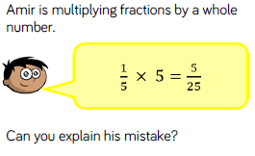
Challenges – You don’t have to try these questions, but if you do think carefully when explaining the answers
_________________________________________________________________________________________________________________________________________________________________________________________________________________________________________________________________

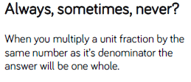
_________________________________________________________________________________________________________________________________________________________________________________________________________________________________________________________________
A unit fraction has 1 as the numerator.

