I can subtract fractions with different denominators.
When subtracting fractions with different denominators, we treat them the same as adding.
Part 1 – Use the diagrams to help you solve the subtraction questions.
Step 1 – Draw the bar model
Step 2 - Colour in the fraction you start with
Step 3 – Spilt the diagram into the amount of the second denominator
Step 4 – Cross out the amount of the second fraction
- 1/2 – 1/4 = b. 1/3 – 1/6 = c. 2/4 – 3/8 = d. 2/3 – 2/6 =

e. 4/5 – 3/10 = f. 3/6 – 5/12 = g. 5/7 – 4/14 = h.7/10 – 11/20 =

Part 2 – Solve these calculations by changing the denominators.
Step 1 – Change the fractions so they have the same denominator
Step 2 – Subtract the numerators
E.g. 1/3 – 1/6 1/3 = 2/6 2/6 – 1/6 = 1/6

- 2/3 – 3/6 =
- 3/4 – 1/2 =
- 3/4 - 2/8 =
- 7/9 – 1/3 =
- 9/10 – 2/3 =
- 6/7 – 2/3 =

Part 3 – Find the missing fraction
Use the inverse to find the missing fractions in the calculations
(Hint: You need to use subtraction to find each answer)
e.g. 3/5 - _____ = 1/10 3/5 – 1/10 3/5 = 6/10 6/10 – 1/10 = 5/10
- 2/3 - _____ = 1/6
- 5/7 - _____ = 4/21
- 3/4 - _____ = 8/12
- 4/5 - _____= 3/20

e.g. _____ + 2/3 = 5/6 5/6 – 2/3 2/3 = 4/6 5/6 - 4/6 = 1/6
- _____ + 3/4 = 11/12
- _____ + 4/5 = 20/20
- _____ + 2/11 = 30/33
- _____ + 2/3 = 4/5

Part 4 - Find the missing digits on the number line
Use subtraction to find the missing digits on the number lines.
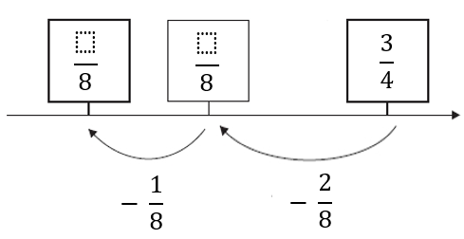
E.g. 3 /4 – 2/8
3/4 = 6/8
6/8 – 2/8 = 4/8
4/8 – 1/8 = 3/8
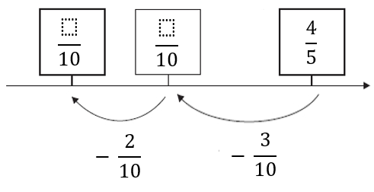

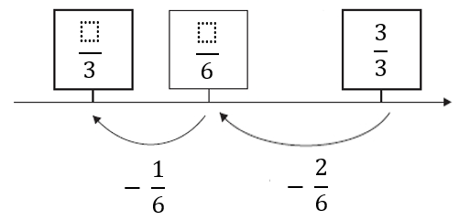

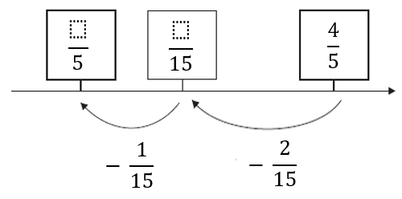

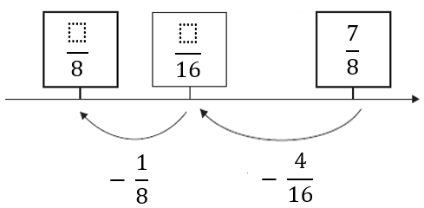

Challenge – Find the missing length of the rectangle.
Remember that opposite sides are the same length in a rectangle.
Use your addition and subtraction knowledge to figure out the length of the missing side. (Pictures not to scale)
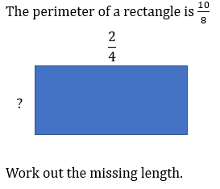
E.g. 2/4 = 4/8
4/8 + 4/8 = 8/8
10/8 – 8/8 = 2/8
2/8 split between 2 = 1/8

