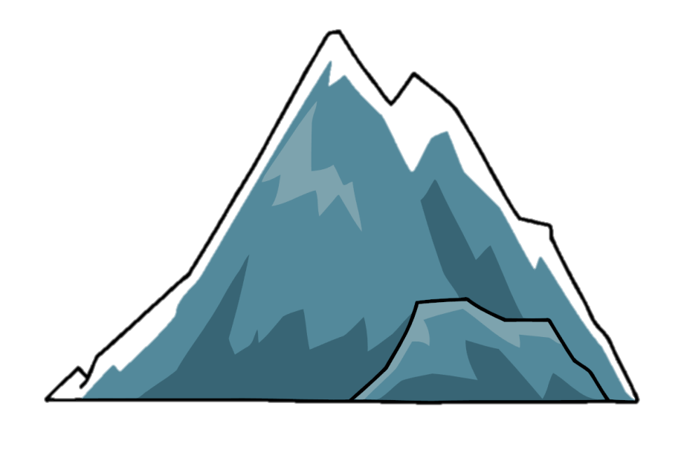

Problem

The blue whale gets distracted and crashes into an old shipwreck. He is confused and can’t find his way.

Resolution

A friend helps the blue whale with his problem. The blue whale can finish his journey.

Ending

The blue whale reaches the equator.

Journey

The blue whale starts his journey to the equator. He sees lots of beautiful sea life on his way.

Opening

The blue whale knows he needs to migrate for the winter because the sea is getting colder.

Journey

Feelings- excited, hopeful, little bit worried.

Sentence openers- A moment later…

After what felt like years…

Gliding through the ocean’s rippling surface…

Journey

Movement description- The tail created a wave as big as a tsunami.

His muscular, slender body rippled through the emerald ocean.

Sea description- vast, open, scary, glistening.

Opening

Setting description- The rippling paradise shimmered like a rare jewel. Multi-coloured coral swayed like a waving hand.

Whale facts- Whales migrate to the equator for winter. They jump out of the water and make large splashes with their tale.

Opening

Opening sentence- As the hammering rollers began to flood the seabed with icy currents, the blue whale knew winter was coming.

Whale description- clumsy, lots of bumpy, barnacles. knobbly body, great, muscular.

Ending

Whale facts- Eat large groups of krill.

Krill gets caught in their baleen plates.

Ending

Ending sentence- The blue whale was finally where he belonged in the warm, comforting ocean with a full, contented belly of krill.

Resolution

Feelings- relieved, the shimmer of hope inside had returned, grateful.

Whale facts- Even though whales normally travel alone, he was so relieved to have found a friend to help on his journey.

Resolution

Friend description- A seahorse with a beautiful gradient of pink faded into purple.

Kind and helpful

Zoomed through the navy-blue ocean.

Problem

Feelings- confused, daunted, panicked, alone, helpless.

Suspense vocabulary- He felt so alone. He felt so scared.

He tried to hum for help but the loud, deep hums were not reaching his friends.

He looked left and right.   
Nervously…

Problem

What is the problem?

The blue whale got distracted by dolphins dancing and flipping out of the water. He crashed into an old shipwreck leaving him with a pounding head and confused where he was.