St Mark’s RE at home
The purpose of these activities is to provide your children with a time of reflection and focus in the period leading up to and beyond Easter. You may want to choose an activity each day, or just do one or two each week. This is not RE as we would do it at school, but a resource to support your child’s understanding of the Christian celebration of Easter.
You may have a more creative way in which to share the story, please use these, or not as you wish.

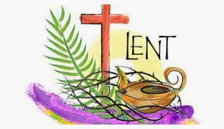
School Values Weekly Bible Reading Challenge
Faith Forgiveness Hope Love
Then Jesus was led by the Spirit into the wilderness to be tempted by the devil.
(Matthew Ch4 v1)
In your opinion, which school value does this Bible verse link to the best and why?

Lent is a time of preparation.
Write or draw a picture of something you are preparing for in the future.
Write a prayer that includes a thank you to God, saying sorry to God and asking God to help you with situations that you find difficult.
Ask an adult to help you!
Lent is a time to forgive others and to receive forgiveness – is there someone who you need to show forgiveness to?
Lent is a time for saying sorry.
Think of someone that you need to say sorry to – speak to them or send a card to show that you are sorry.
RE at Home Week 1: Lent

