18.3.20
I can draw a pictogram
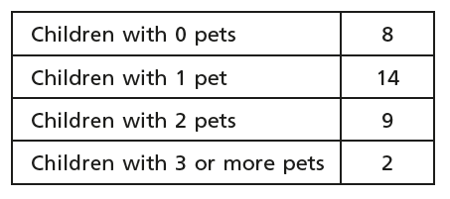
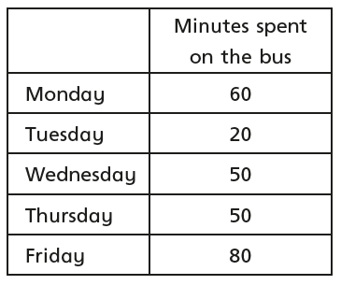
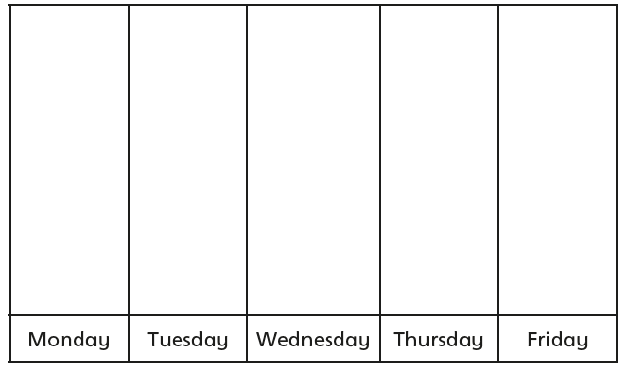

A) Create a pictogram to show the information in the table. Use a key where 1 symbol represents 2.
Favourite doughnut | Number of children
Strawberry Jam | 10
Custard | 7
Blueberry | 4
Raspberry Jam | 8
Vanilla | 5

Favourite doughnut | Number of children
Strawberry Jam
Custard
Blueberry
Raspberry Jam
Vanilla

B) Create a pictogram to represent the information in the table. Choose your own key.

Favourite colours | Number of children
Red | 20
Blue | 35
yellow | 15
Green | 10
purple | 30

Favourite Colours | Number of children
Red

Blue
Yellow
Green
Purple

Reasoning activity
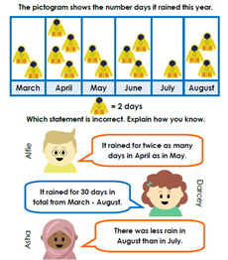

Challenge task
