I can use descriptive language in an adventure story

Expanded Noun Phrases
The purple, gentle seahorse bobbed through the deep, dark sea.
Adjectives
angry | jolly
attractive | lazy
big | little
beautiful | lively
cherry-red | kind
clumsy | microscopic
colossal | multi-coloured
dazzling | mysterious
embarrassed | pearl-grey
emerald | ruby
elegant | scarlet
gentle | scrawny
gigantic | sky-blue
great | stocky
happy | stripy
huge | spotty
immense | worried

I can use descriptive language in an adventure story

Similes
As gentle as a feather, the turtle floated past the brightly coloured coral.
Similes
As timid as …
As quiet as …
As scared as …
As quick as …
As slowly as …
As angry as …
As calmly as …
As noisy as …
As high as …
Like a tree …
Like a plank of wood …
Like a lion …
Like the sun …
Like a monster …
Like a villain …
Like a mythical god …

I can use descriptive language in an adventure story

Story Language
Beginning:
A long, long time ago …
The blue whale yawned …
The sun rose …
Far, far away …
The sea lapped around …
One morning …

Middle:
Suddenly,
All of a sudden,
Just at that moment,
A while later,
As he began his …
In the distance,

Ending:
As the sun set,
Soon
Eventually
Before long

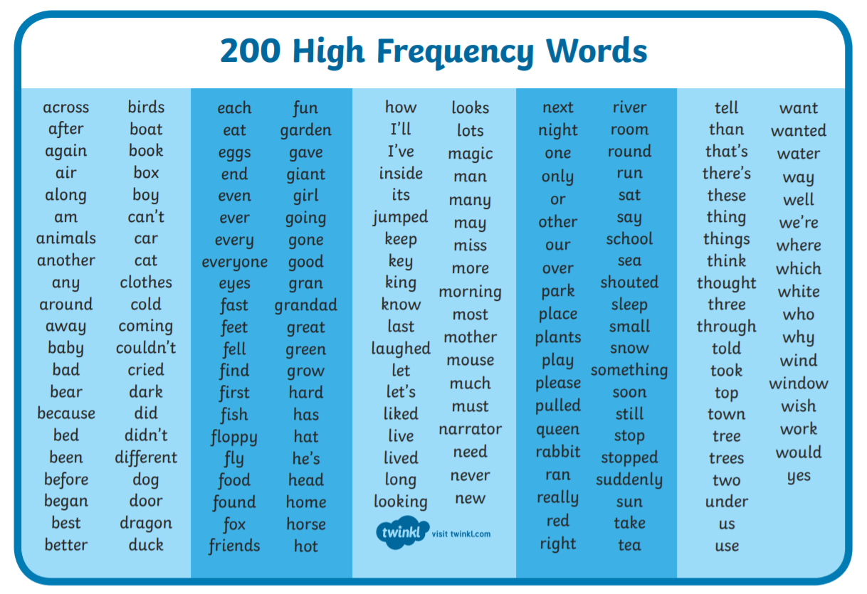
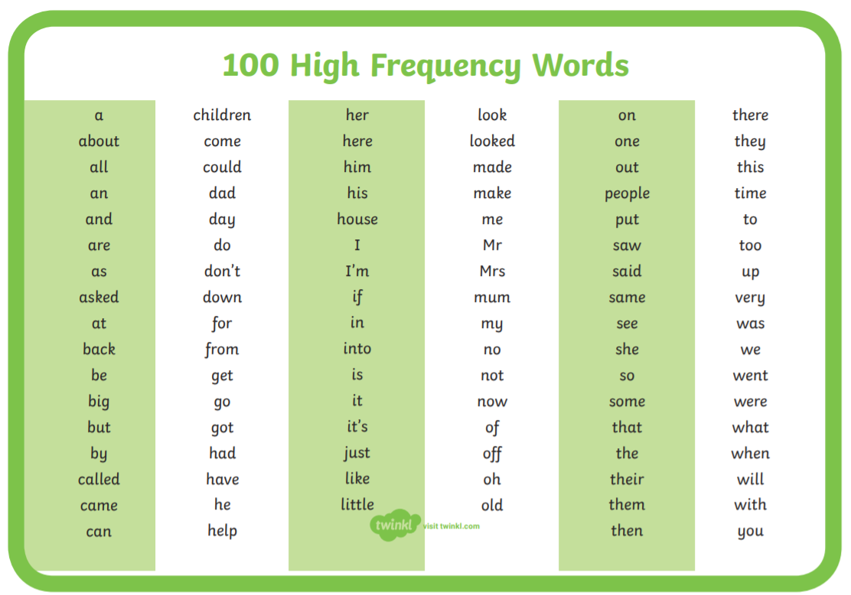
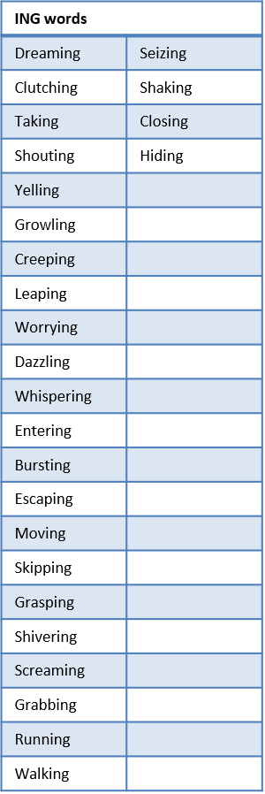
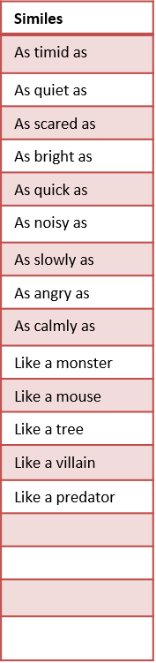
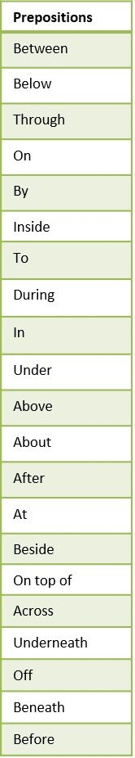
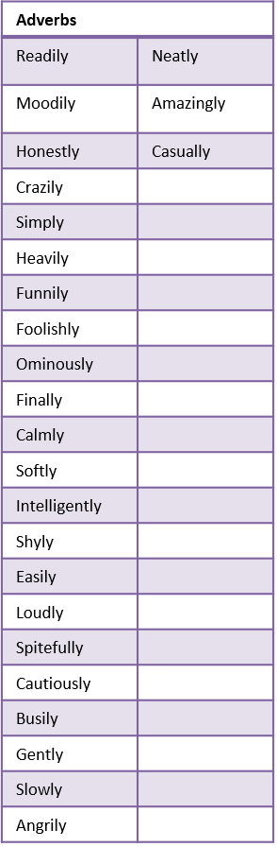
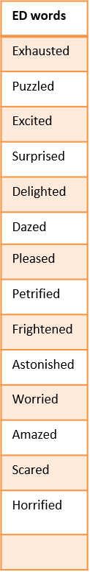
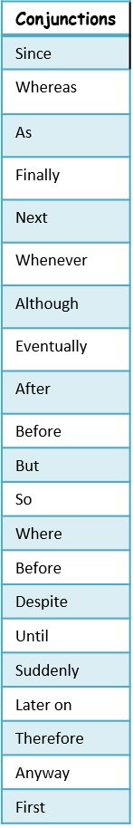
I
E
C
A
P
S

