Start time |  | One hour later
Quarter past 1 | 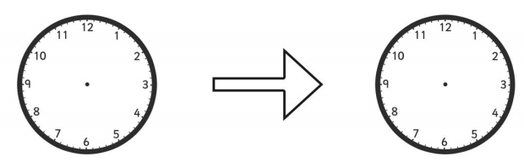
Quarter past 2
Quarter past 3
Quarter past 4
Early Eric is always half an hour early. Late Liam is always half an hour late.
What time do they arrive?
Early Eric | Draw the hands on the clock | Late Liam
 | Swimming Quarter past 9
 | Lunch Quarter past 12
 | Football Quarter past 4
25.03.20 I can find time intervals.

