I can understand units of measurement
Which unit of measurement would you use to measure the objects?
Metres (M), Centimetres (cm), Millimetres (mm)
Fingernail 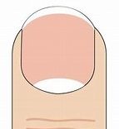
Rubber 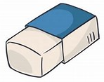
Length of a table 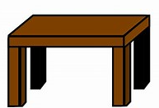
Length of a paperclip 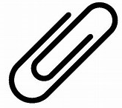
Length of a pencil 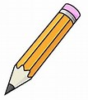
Length of a sharpener 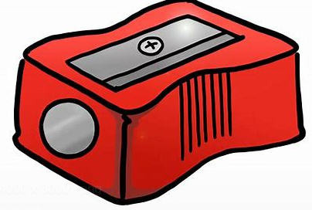
Height of a house
Length of the playground. 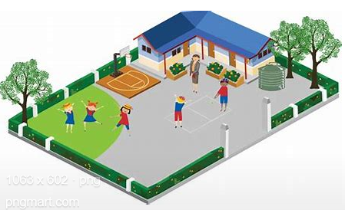

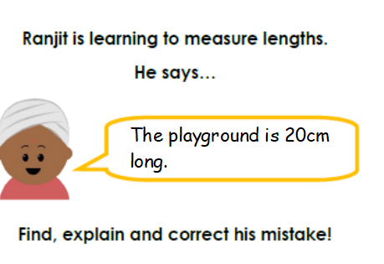 | He is __________________ because _______________  ______________________  ______________________  ______________________
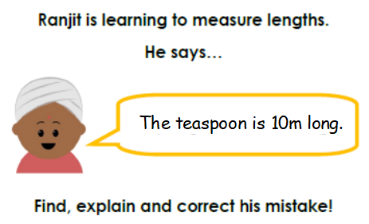 | He is __________________ because _______________  ______________________  ______________________  ______________________
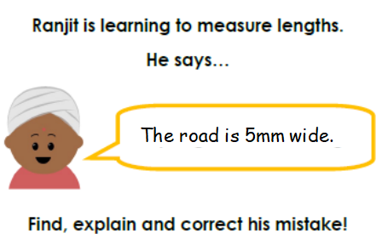 | He is __________________ because _______________  ______________________  ______________________  ______________________

