I can measure length
What is the length of each line?
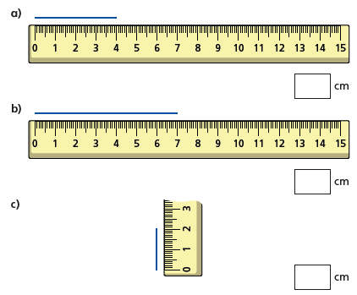
Write the length to the nearest millimetre. Remember 1cm = 10mm
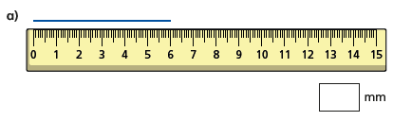
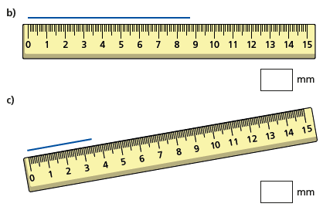

Use a ruler to draw lines these lengths.
30mm

45mm

65mm

85mm

87mm

How long is the paintbrush?
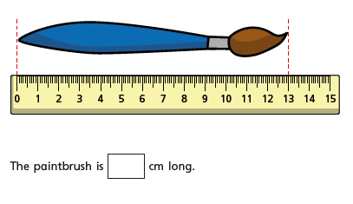
How long is the toy car?
