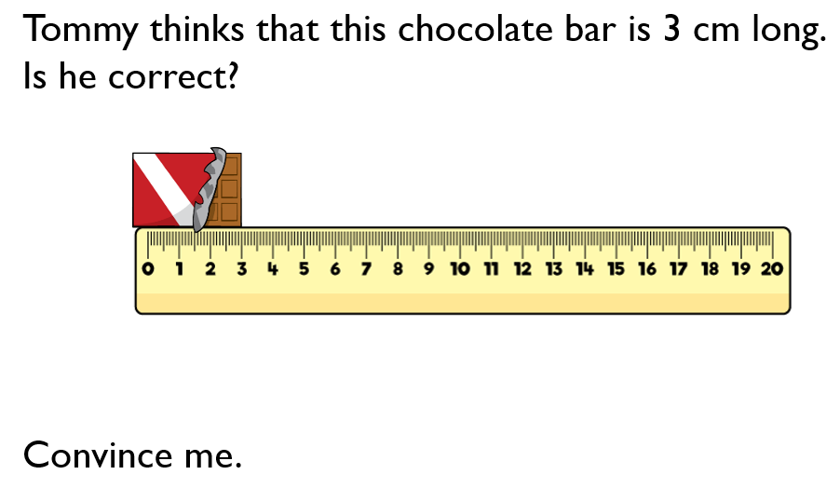 | Tommy is _______________  because ________________  ______________________  ______________________  ______________________
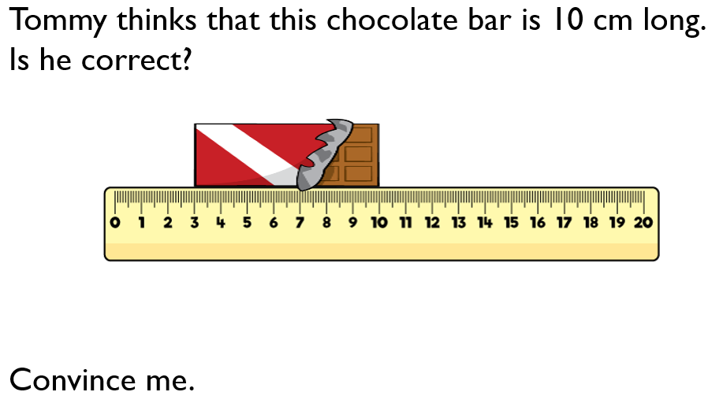 | Tommy is _______________  because ________________  ______________________  ______________________  ______________________
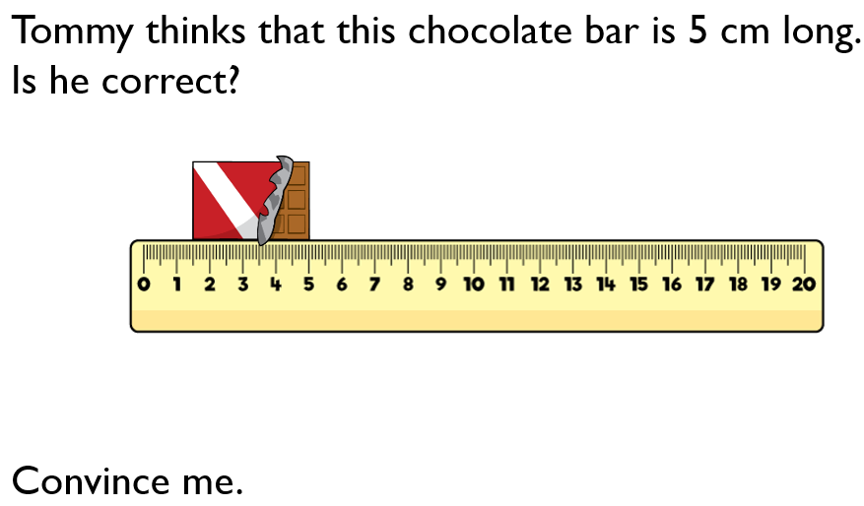 | Tommy is _______________  because ________________  ______________________  ______________________  ______________________

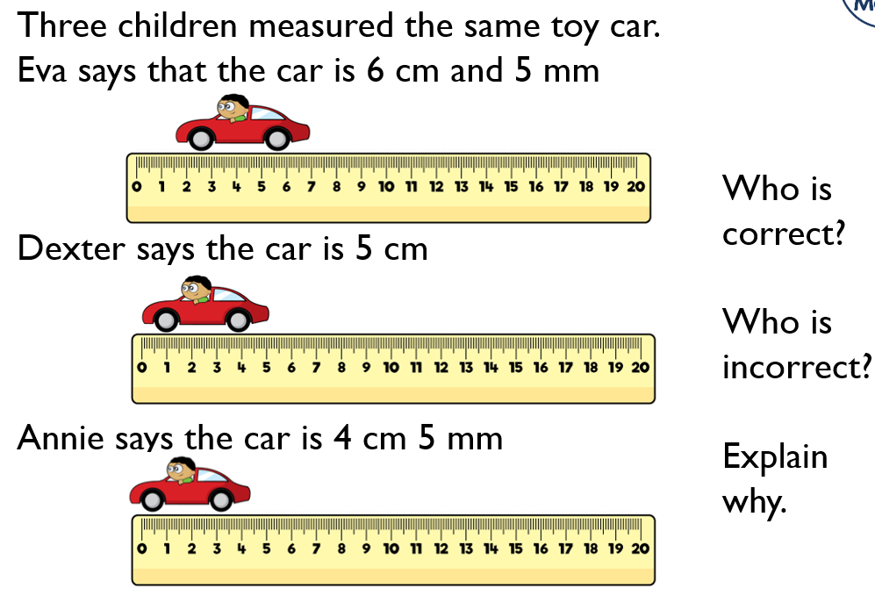 | ______________ is correct because________________  ______________________  ______________________  ______________________  ______________________  ______________________
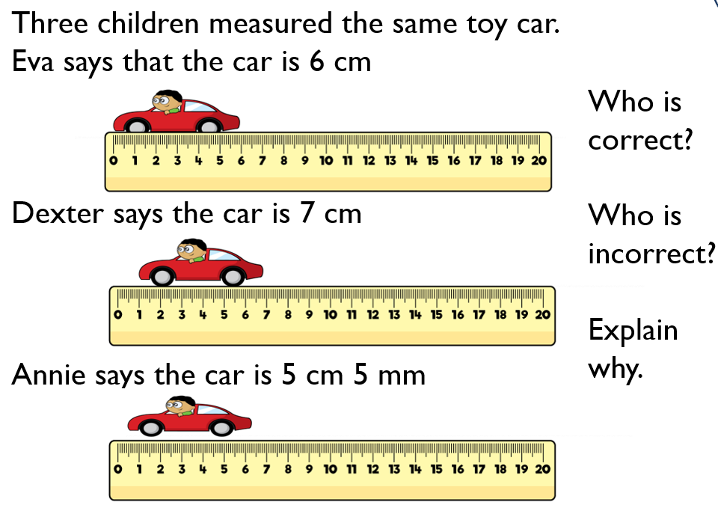 | ______________ is correct because________________  ______________________  ______________________  ______________________  ______________________  ______________________

