I know 1m = 100cm
Fill in the blanks and complete the bar models.
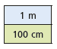
1m = 100cm There is _____cm in 1m
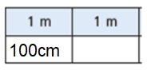
2m = ______cm There is ______cm in 2m
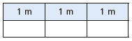
3m = ______cm There is _______cm in 3m.

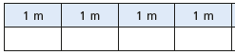
4m = _____cm There is ______cm in 4m

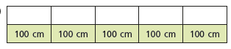
There are 500cm = _______ m

Match the equivalent measurements.
600cm |  | 400cm
300cm |  | 9m
8m |  | 700cm
4m |  | 6m
900cm |  | 800cm
7m |  | 3m

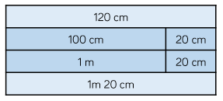
Eva uses this diagram to convert cm to m.
Use this model to convert the following the cm.

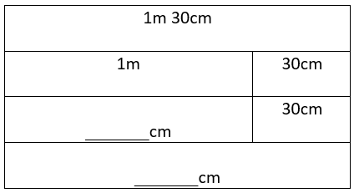 | 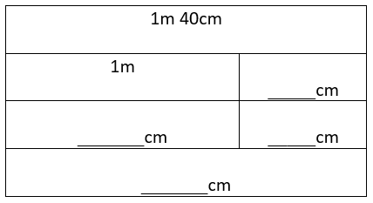 | 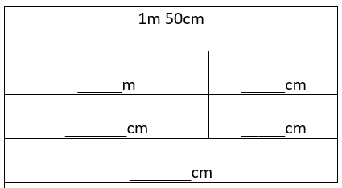
Complete the table to show equivalent lengths and complete the pattern.
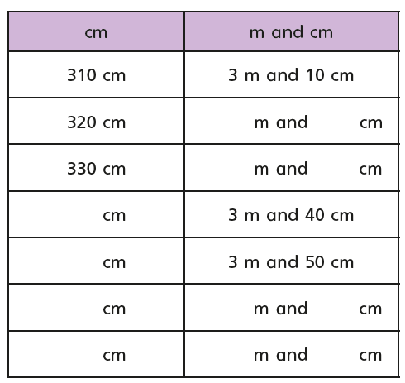
Write the missing measurements.
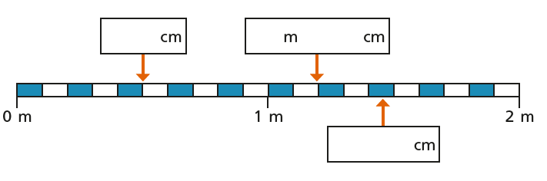
Reasoning
Remember ½ m = 50cm
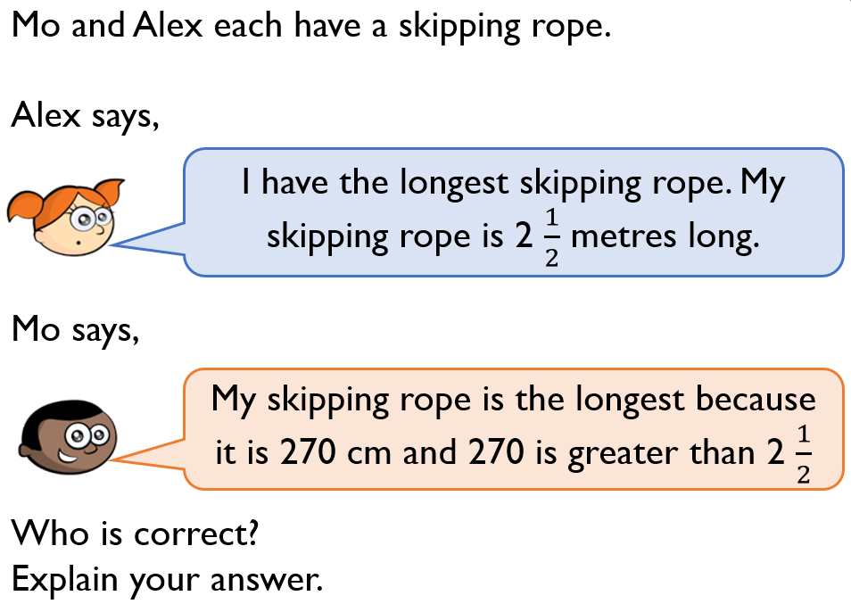 | __________ is correct because 2 ½ m is equivalent to _____________________  _______________________________  __________________________________  __________________________________  __________________________________
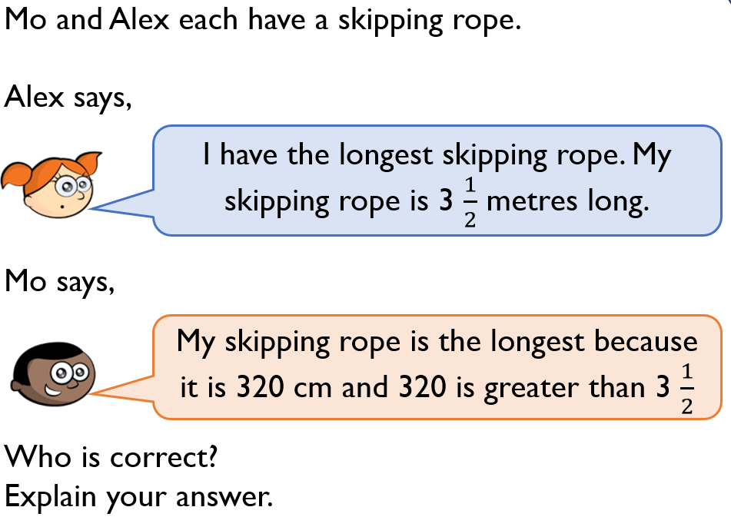 | __________ is correct because 3 ½ m is equivalent to _____________________  _______________________________  __________________________________  __________________________________  __________________________________

