19.3.20
I can interpret information in a bar chart.
Some children were asked about their favourite fruits.
The bar chart shows the results.
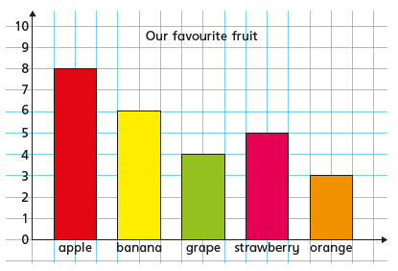

- What was the most popular fruit?
- What was the least popular fruit?
- How many more children liked bananas than oranges?
- How many more children liked apples than grapes?
- How many children were asked in total?
This bar chart shows how many gold medals were won by each country at the olympics.

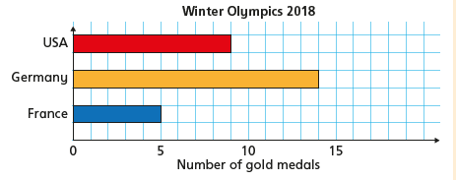
- Which country won the most medals? How many did they win?

- How many more medals did the USA win than Germany?

- What’s the difference between the number of medals France and USA won?

- How many medals did the 3 countries win in total?

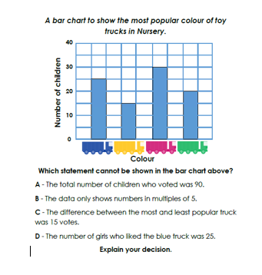
Reasoning Task
Look carefully at the bar chart below.
What does it represent?
What scale is used?

