Challenges – Tuesday 31st March

Part 1
a. Dexter says there is only one way to partition 0.62.
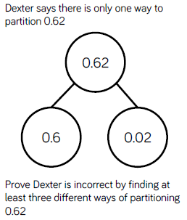
Prove Dexter is incorrect by finding at least three different ways of partitioning 0.62.

b. Find five different ways of partitioning 0.84.
0.84
0.84
0.84
0.84
0.84

Part 2
Match each description to the correct number.
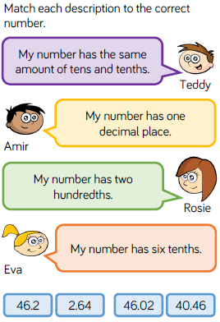
a.
Teddy’s Number –
Amir’s Number –
Rosie’s Number –
Eva’s Number -

b. Write the clues that the children will say to help someone guess which number is theirs.
Teddy’s Number – 6.34
Amir’s Number – 2.35
Rosie’s Number – 6.78
Eva’s Number – 34. 3

