Challenges – Wednesday 1st April

# Part 1

In each question, circle which one you think is the odd one out and then underneath explain why that one is the odd one out.

a.

|  |  |  |  |
| --- | --- | --- | --- |
| A | B | C | D |

Explain: _________________________________________________________ ________________________________________________________________________________________________________________________________________________________________________________________________

|  |  |  |  |
| --- | --- | --- | --- |
|  |  |  |  |

b.

Explain: _________________________________________________________ ________________________________________________________________________________________________________________________________________________________________________________________________

# Part 2

Complete the two part whole models below

a. b.

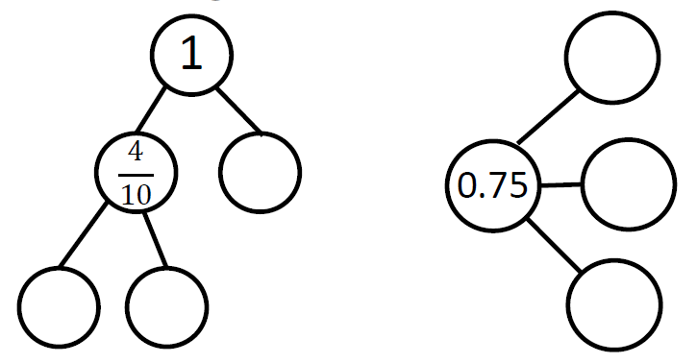

# Part 3

**a.**

Tick the **two** numbers that are equivalent to 

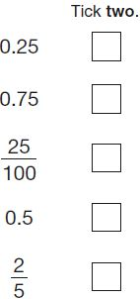

1 mark

**b.**

Put a tick (✔) in **each row** to complete this table.

One has been done for you.

|  |  |  |
| --- | --- | --- |
|  |  |  |
| **0.9** | ✔ |  |
| **0.06** |  |  |
|  |  |  |
| **0.21** |  |  |

2 marks