I can find a fraction of an amount and multiply a fraction

Part 1 - Fill in the gaps, using what you know about fractions.
2 x $\frac{1}{10}$ = $\frac{2}{10}$ | ½ of 2 = 1
8 x ¼ = | ¼ of 8 =
x $\frac{1}{5}$ = 2 | of 9 = 3
7 x = $\frac{7}{10}$ | of 15 = 3
x $\frac{1}{6}$ = 1$\frac{5}{6}$ | $\frac{1}{10}$ of = 2

Is it easier to multiply a fraction or find a fraction of an amount? Explain your answer.
________________________________________________________________________________________________________________________________________________________________________

Part 2 –Use what we have learnt about fractions to answer these SATs style questions.
Q1.

Calculate of 325 =

1 mark
Q2.

Calculate of 88 =

1 mark
Q3.
Calculate of 1275 =

Q4.

Calculate of £15 =

1 mark
Q5.
Calculate of 288
1 mark
Q6.
Tick the fractions less than

2 marks
Q7.

Here is a chocolate bar.
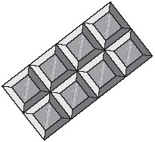
William eats 3 pieces and Amber eats 2 pieces.
What fraction of the chocolate bar remains?

1 mark
Q8.
A fraction of each shape is shaded.
Match each fraction to the correct place on the number line.
One has been done for you.

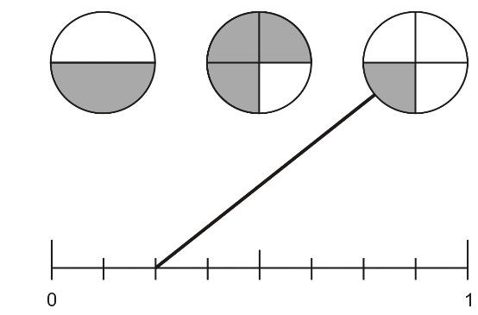
1 mark
Q9.

The diagram is made of squares.
What fraction of the diagram is shaded?

1 mark

Q10.

Two of the fractions below are equivalent.
Circle them.
1 mark

Q11.
These diagrams show three equivalent fractions.
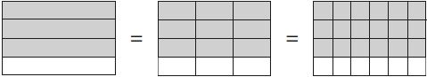
Write the missing values.
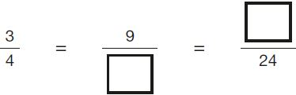
1 mark
Q12.

Here are five number cards.

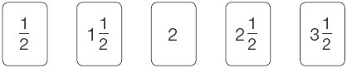
Use three of the number cards to make this calculation correct.

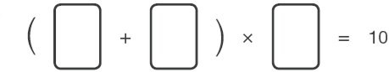
1 mark

Q13.
Circle the improper fraction that is equivalent to
1 mark

Q14.

Write the missing fraction.

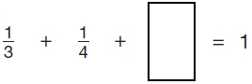
1 mark
Q15.

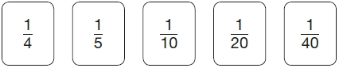
Use three of these fraction cards to complete the sum below.

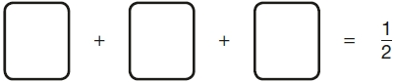
1 mark
Q16.

Write the two missing values to make these equivalent fractions correct.
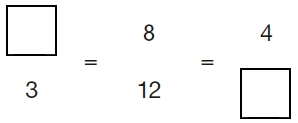
2 marks
Q17.

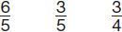
Write these fractions in order, starting with the smallest.
1 mark
Q18.

The numbers in this sequence increase by the same amount each time.
Write the missing numbers.
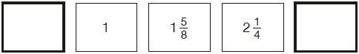
2 marks

