I can multiply a non-unit fractions by an whole number.
Part 1 – Complete the missing sections of the table
Calculation | Repeated addition | Pictorial | Answer
3 x $\frac{2}{3}$ | $$\frac{2}{3}+\frac{2}{3}+\frac{2}{3}$$ |  | $$\frac{6}{3}=2$$
4 x $\frac{2}{4}$ | $$\frac{2}{4}+\frac{2}{4}+\frac{2}{4}+\frac{2}{4}$$
$\frac{3}{5}$ x 3 | $$\frac{3}{5}+\frac{3}{5}+\frac{3}{5}$$
 | $$\frac{3}{4}+\frac{3}{4}+\frac{3}{4}$$
 |  |  | $$\frac{25}{6}=4\frac{1}{6}$$

Part 2 - Complete the missing parts of the rows below – look carefully at the different bar models
E.g.
Calculation  $\frac{3}{4 }$ x 2 = | Repeated Addition  $\frac{3}{4 }$ + $\frac{3}{4 }$ | Picture | Answer  $\frac{6}{4 }$ = $1\frac{2}{4 }$
a.
Calculation  $\frac{2}{5 }$ x 4 = | Repeated Addition | Picture | Answer
b.
Calculation  $\frac{4}{6 }$ x 5 = | Repeated Addition | Picture | Answer  $\frac{}{6 }$ =
c.
Calculation  $\frac{4}{7}$ x ___ = | Repeated Addition | Picture | Answer  $\frac{24}{7 }$ = 3$\frac{3}{7 }$

Part 3 – Complete the table, using the number lines. You will have to make the number line further down.
Question | Number line | Answer
2 x $\frac{3}{7}$ | 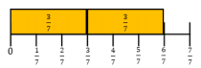 | $$\frac{6}{7}$$
5 x $\frac{2}{12}$ | 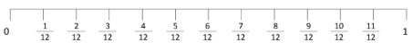
$\frac{4}{12}$ x 3

$\frac{2}{8}$ x 4 | 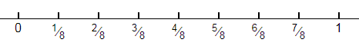
 | 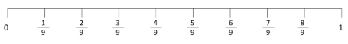 | $$\frac{8}{9}$$
$\frac{3}{16}$ x 5

 |  | $$\frac{9}{10}$$

Part 4 – Use your multiplication knowledge to work out these calculations without the visuals
Step 1: Write your denominator for your answer.
Step 2: Multiply your numerator by the whole number.
Step 3: Simplify fractions if possible or write as a mixed number.
$e. g. \frac{2}{6}x 2=\frac{4}{6}= \frac{2}{3}$
- $\frac{2}{4}x 2=$
- $\frac{4}{10}x 3=$
- $\frac{3}{6}x 4=$
- $\frac{3}{11}x 7=$
- $\frac{4}{8}x 5=$
- $\frac{3}{10}x 8=$
Challenge – Use the digit cards to complete these multiplications (only use each card once for each calculation). The first one is really tricky!!
a.

Find as many different answers as you can for this one.
b.

