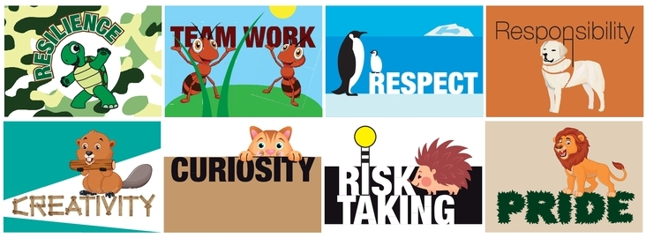

Weekly Spellings
Each week your child will bring home some spellings on a Friday. Practising these with your child at home will support their progress in both reading and writing and is hugely important. They will complete a test on these spellings or spellings with a similar pattern on the following Friday.
Spring 2/Week 6 Spelling Rule: Common exception words
 | Monday | Tuesday | Wednesday | Thursday | Friday
mischievous
muscle
nuisance
restaurant
prejudice
stomach
thorough
yacht

Other activities to support spelling and understanding of new vocabulary:
- Dictate sentences with the spelling words in them
- Use a dictionary to look up the words and write a definition of their meaning
- Find synonyms (words with a similar meaning)
- Look for other words with the same spelling patterns

