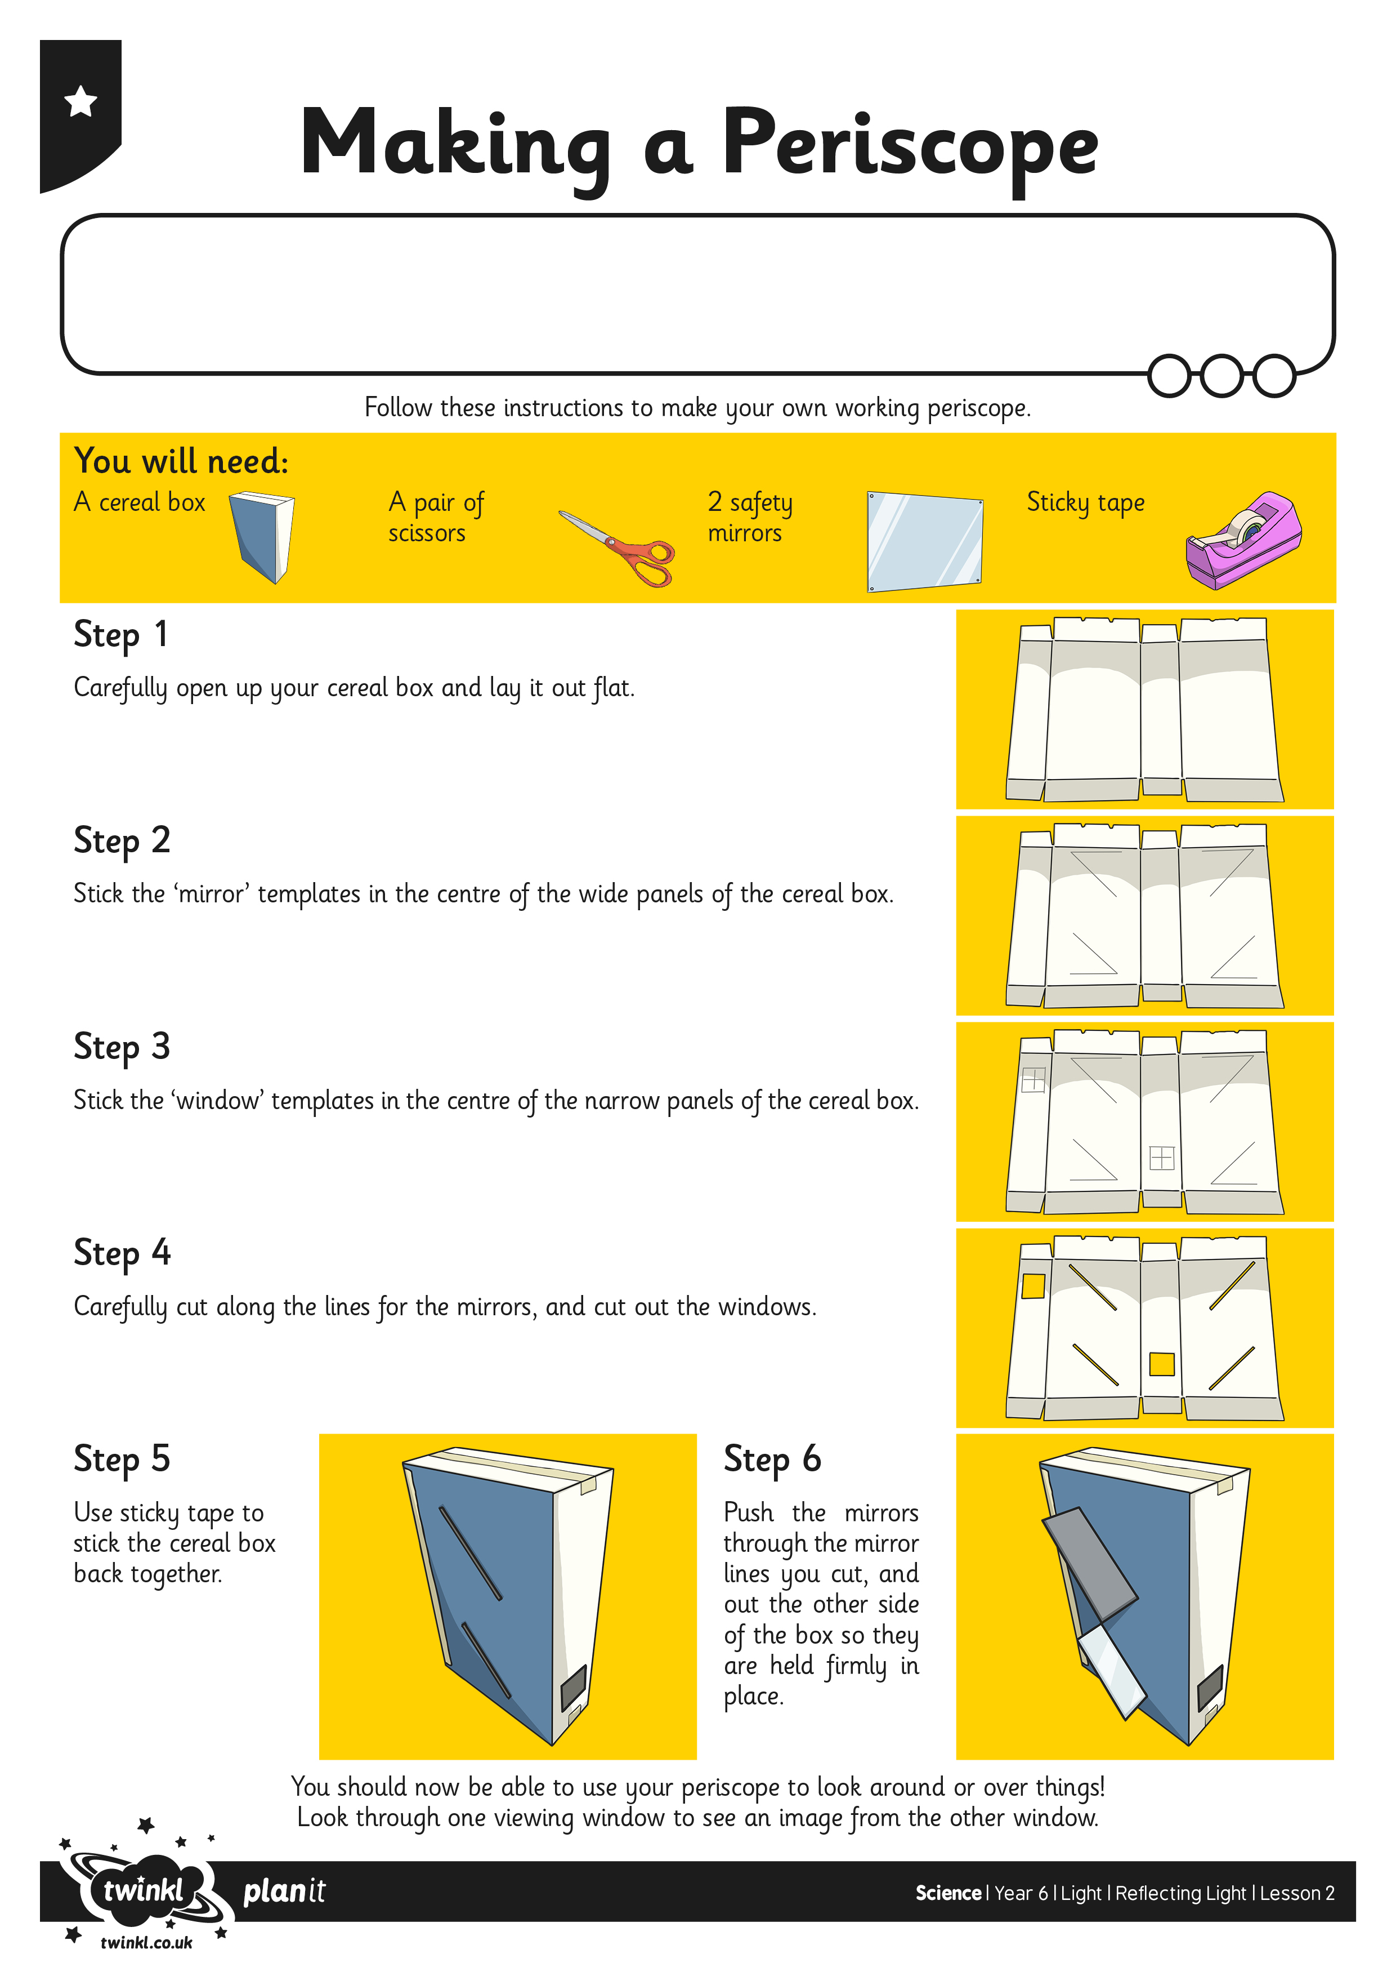
I can use my understanding of reflection to create a working periscope.
I can explain how the periscope allows me to see objects I would not usually be able to see.

