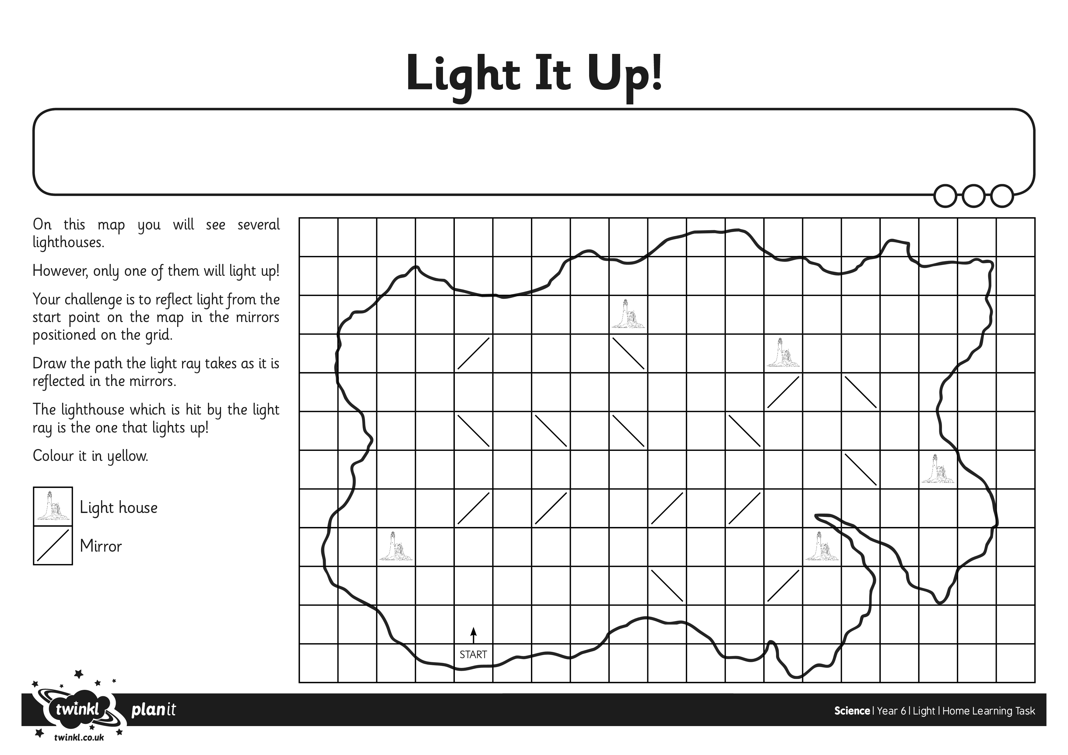
I can demonstrate and explain how reflection works

