- 1.5 ÷ 5 = 0.3
- 1.5 ÷ 3 = 0.5
- 1.8 ÷ 3 = 0.6
- 2.4 ÷ 6 = 0.4
- 5.6 ÷ 7 = 0.8
- 4.9 ÷ 7 = 0.7
- 9.1 ÷7 = 1.3
- 12.6 ÷ 9 = 1.4
- A stack of 3 identical books is 2.7 cm tall.  Amy takes one book off the top.  How tall is the stack now? 1.8cm | - A stack of 3 identical books is 3.9 cm tall.  Rhys takes two books off the top.  How tall is the stack now? 1.3cm
- A stack of 4 identical books is 5.2 cm tall.  Zach takes two books off the top.  How tall is the stack now? 2.6cm | - A stack of 5 identical books is 6.05 cm tall.  Jake takes two books off the top.  How tall is the stack now? 3.63cm
- A stack of 7 identical books is 9.8 cm tall.  Freddie takes two books off the top.  How tall is the stack now? 7cm | - A stack of 6 identical books is 37.2 cm tall.  Isla takes three books off the top.  How tall is the stack now? 18.6cm
- A stack of 8 identical books is 24.8 cm tall.  Carol takes two books off the top.  How tall is the stack now? 18.6cm | - A stack of 5 identical books is 46.5 cm tall.  Connor takes 3 books off the top.  How tall is the stack now? 18.6cm

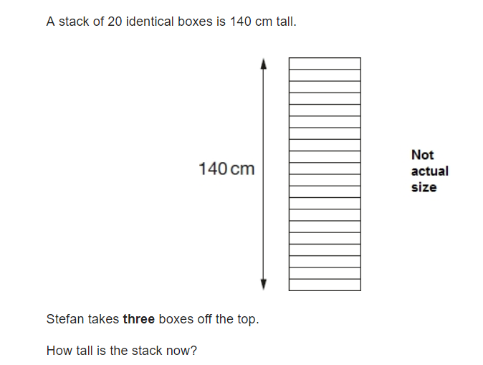
Can you solve this SATs question?

119cm

