- 1.5 ÷ 5 = 0.3
- 1.5 ÷ 3 = 0.5
- 1.8 ÷ 3 = 0.6
- 2.4 ÷ 6 = 0.4
- 5.6 ÷ 7 = 0.8
- 4.9 ÷ 7 = 0.7
- 9.1 ÷7 = 1.3
- 12.6 ÷ 9 = 1.4
- A stack of 3 identical books is 2.7 cm tall.  Amy takes one book off the top.  How tall is the stack now? 1.8cm | - A stack of 3 identical books is 3.9 cm tall.  Rhys takes two books off the top.  How tall is the stack now? 1.3cm
c)A stack of 4 identical books is 5.2 cm tall.  Zach takes two books off the top.  How tall is the stack now? 2.6cm | d)A stack of 5 identical books is 6.05 cm tall.  Jake takes two books off the top.  How tall is the stack now? 3.63cm
e)A stack of 7 identical books is 9.8 cm tall.  Freddie takes two books off the top.  How tall is the stack now? 7cm | f)A stack of 13 identical books is 18.2 cm tall.  Isla takes three books off the top.  How tall is the stack now? 14cm
g)A stack of 23 identical books is 10.81 cm tall.  Carol takes two books off the top.  How tall is the stack now? 9.87cm | g)A stack of 24 identical books is 31.68 cm tall.  Connor takes 7 books off the top.  How tall is the stack now? 22.44cm

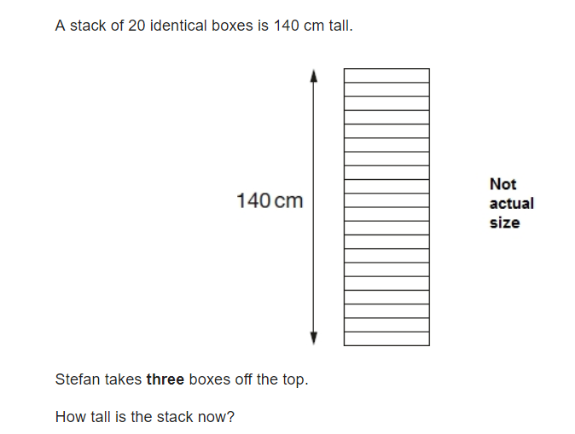
Can you solve this SATs question?

119cm

