25.03.20
AD
S
Owl Babies:
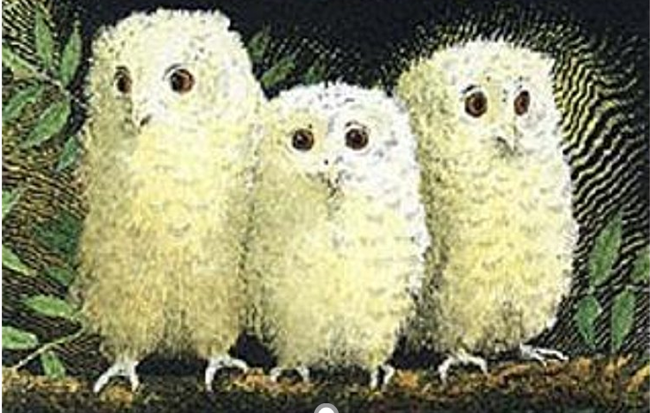
In the deep, dark woods, the Owl Babies could hear………

