I can interpret a table
This table shows the different coloured paints that children used in their art.
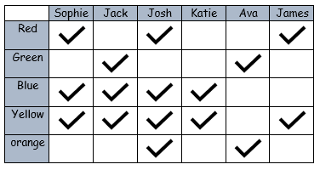
- How many children used green paint? ___________________________
- Which colours did Jack use? _________________________________
- Which children used green? __________________________________
- Which children used red and yellow? ___________________________
- Which child used the most colours? ____________________________
- Which children used the least colours? _________________________
This table shows the increase in price for bus tickets.
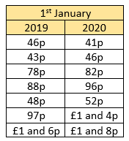
- The cost of Ron’s ticket now is 96p. How much was his ticket last year?
___________________
- Which ticket has increased the most?
___________________
- Which ticket has increased the least?
___________________
- Look at the table below. How many questions can you create about it?



