DIY Cute Animal Bookmarks: How to make Cute Animal Corner Bookmarks

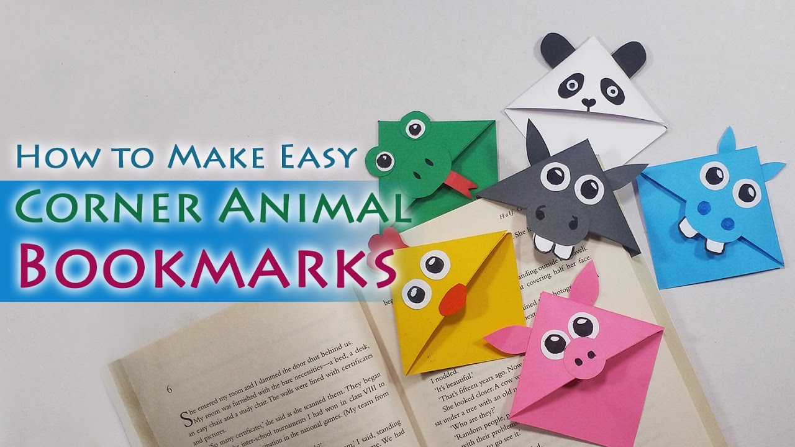
Full demonstration on youtube:
https://www.youtube.com/watch?v=A5rI1SG3Kpw

