[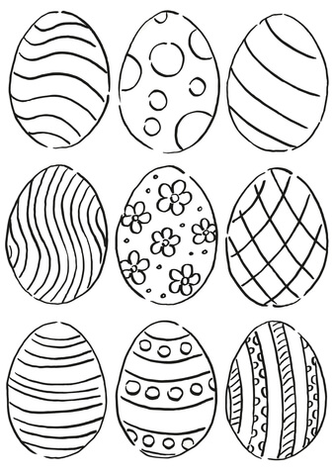](http://www.supercoloring.com/coloring-pages/easter-eggs-pattern?version=print)