Challenges – Friday 1st May

Adding decimals - crossing the whole – Answers!

Part 1

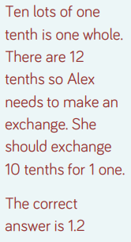

Part 2

