Challenges – Friday 1st May

Adding decimals - crossing the whole

Part 1

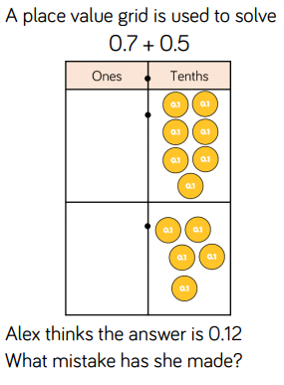
Part 2

