Paper Flower Craft
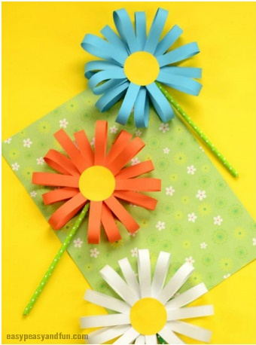
What you need
- yellow paper or a yellow felt tip to colour the paper
- paper in a variety of colours
- scissors
- glue
- drinking straws
- sticky tape

Instructions
First cut a few circles out of yellow paper. You will need one circle for 1 flower.
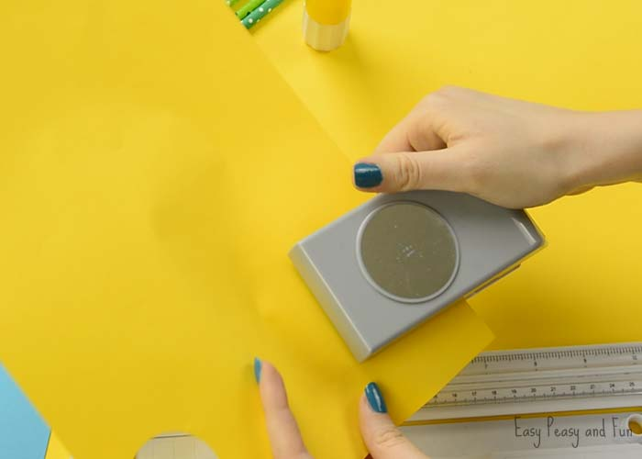
Cut strips of paper. There is some trial and error with the next step. Depending on your circle size, different lengths (and widths) of paper strips will work. We recommend you first make one strip of paper and make a loop (as seen in the next step) and see if it works with your circle size. Once you are happy with the size of the loop in relation to your yellow circle, start cutting strips of paper in that size.
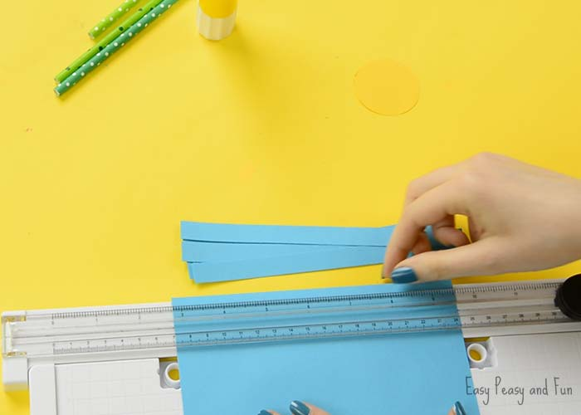

Glue the ends of paper strips together, making a paper loop. You will need quite a few (the number depends on the size of the flower you are making).
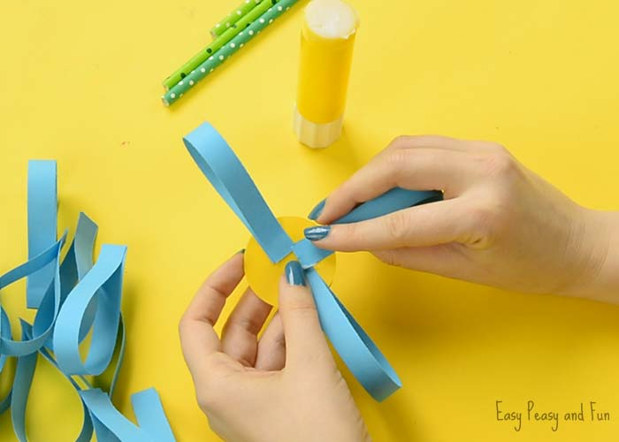
Glue the loops on one side of the paper circle. We started by sticking 4 at a 90° angle, then another 4 in between and another 8 in between those.
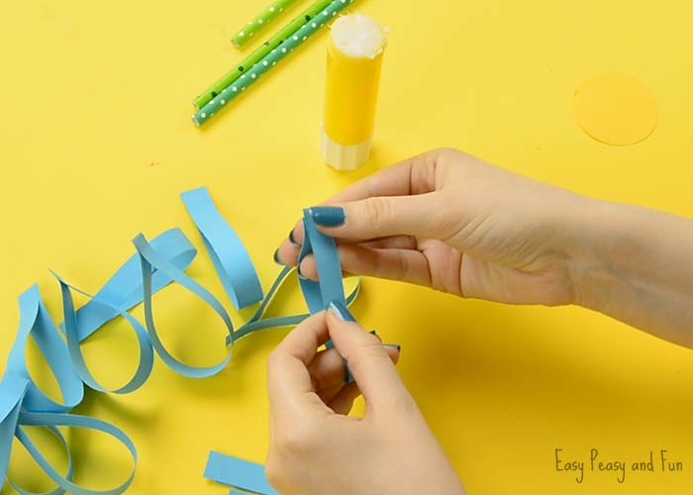
Once you are happy with how full your paper flower craft is looking, apply some glue onto the green paper straw and press it in the middle of the flower.
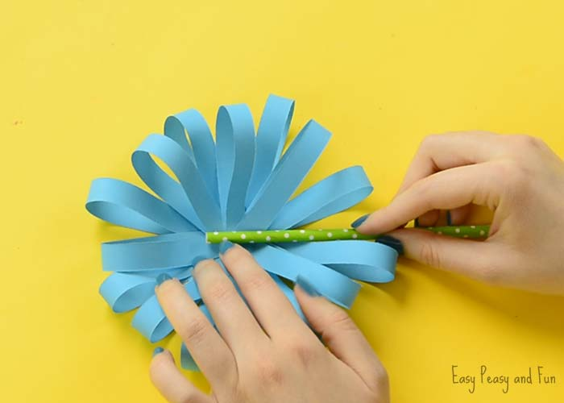
Secure with clear tape.
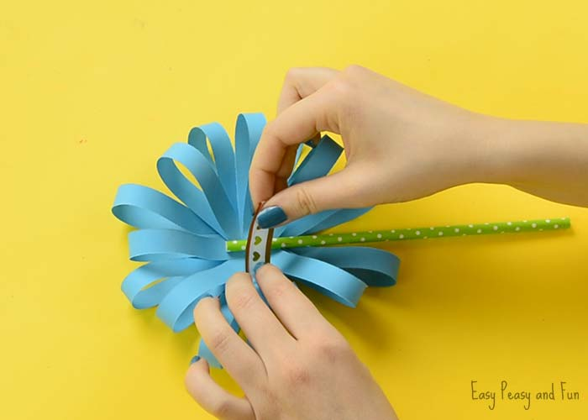
Your paper flower craft is complete.

