Challenges – Thursday 30th April

Complements to 1

Part 1

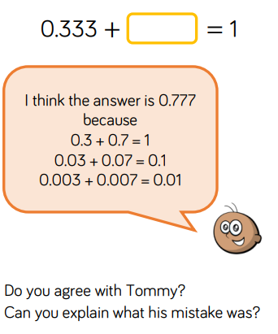

Part 2

