Challenges – Tuesday 28th April

Adding decimals within 1- ANSWERS!

Part 1
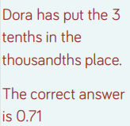

Part 2

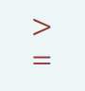
Part 3

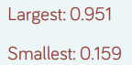

Part 4
Numbers circled as shown:
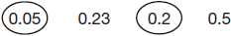

Part 5

Any three decimals which add to make 0.01, eg
0.005 + 0.002 + 0.003

