Challenges – Tuesday 28th April

Adding decimals within 1

Part 1
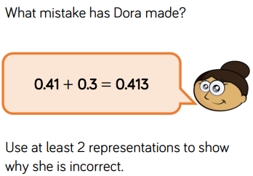

Part 2
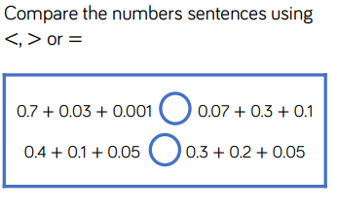

Part 3
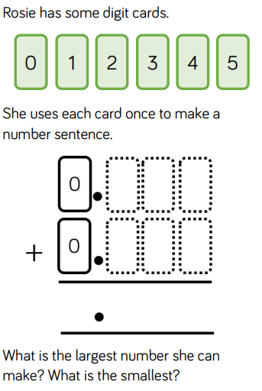
Part 4
Circle two numbers that add together to equal 0.25
0.05 0.23 0.2 0.5
Part 5
Write three decimals, each greater than zero, which add together to make a total of 0.01

 | + |  | + |  | = 0.01

