Challenges – Wednesday 29th April

Subtracting decimals within 1 - Answers

Part 1

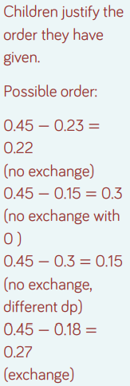

Part 2

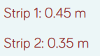

Part 3

Q1.

