Challenges – Wednesday 29th April

Subtracting decimals within 1

Part 1
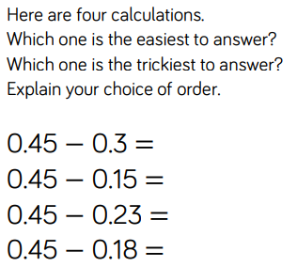

Part 2
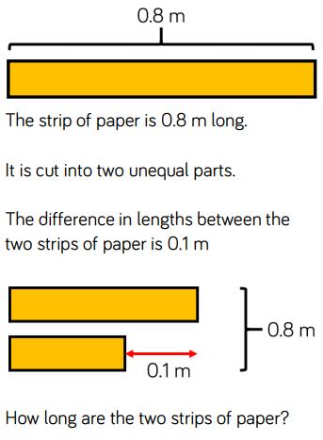
Part 3
Circle two decimals that have a difference of 0.5.

0.2 0.25 0.4 0.45 0.6 0.75

