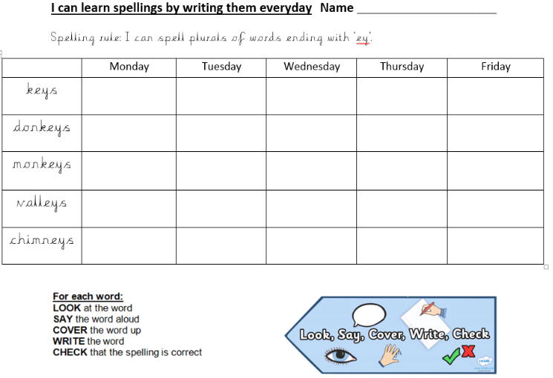

## Spelling rule: The 'ou' sound spelt a after w and qu.

want

watch

wander

quantity

squash