EASTER SOCK BUNNY TUTORIAL

Materials needed for this Easter bunny craft
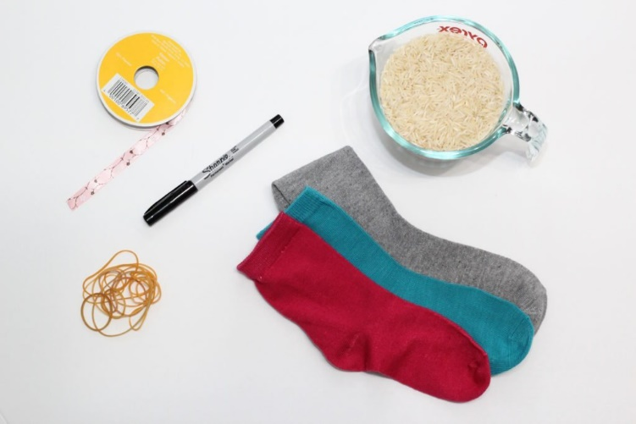
- Unmatched socks
- Uncooked rice (around 1 cup per bunny)
- Elastic bands
- Black Sharpie Marker (or any black marker)
- Pretty Ribbon (Optional)
- Scissors

Instructions for the no sew sock bunny
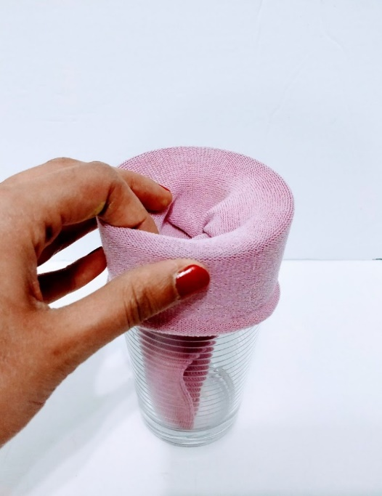
Step 1. Take the sock and place it over a tall glass so its easier to pour the rice into.

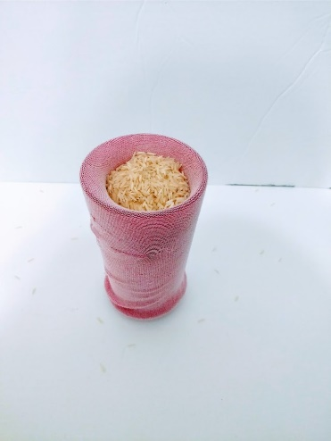
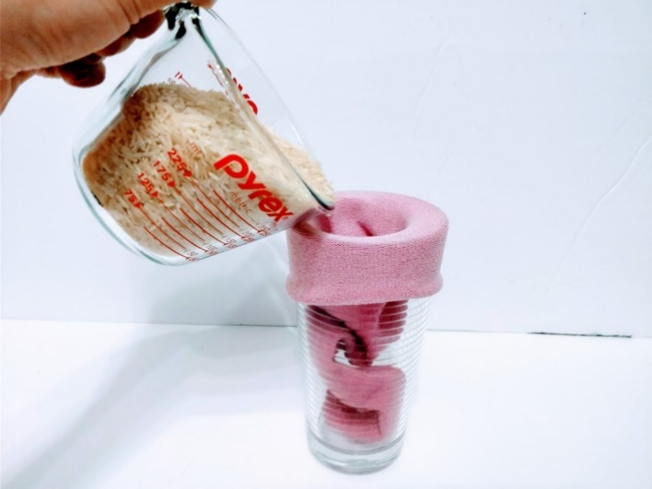
Step 2 Poor the rice into the sock. I used a measuring pyrex cup to make it easier to pour, but you can use anything.

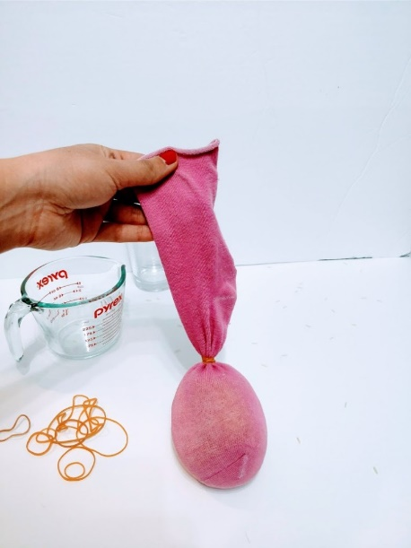
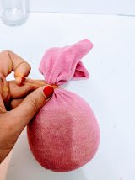
Step 3: Take the rubber band and tie the top close

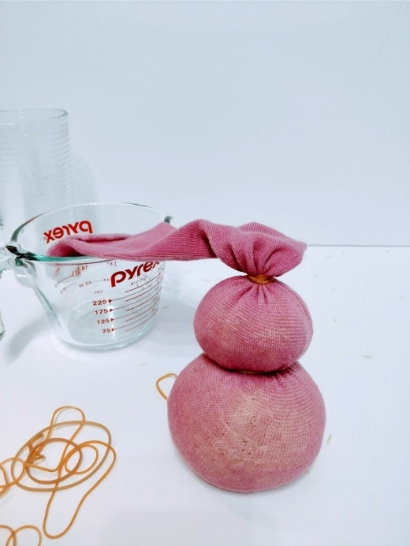
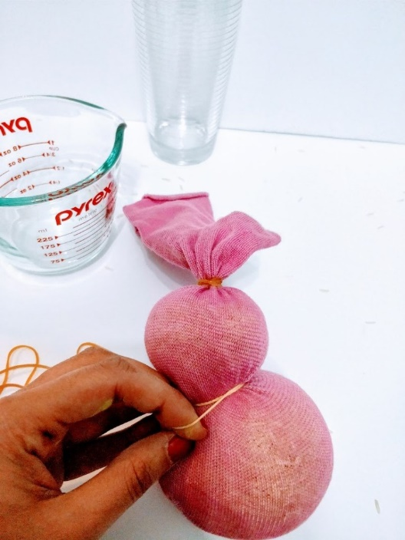
Step 4: To make the head and body shape, take another rubber band and tie it between the head and the body.
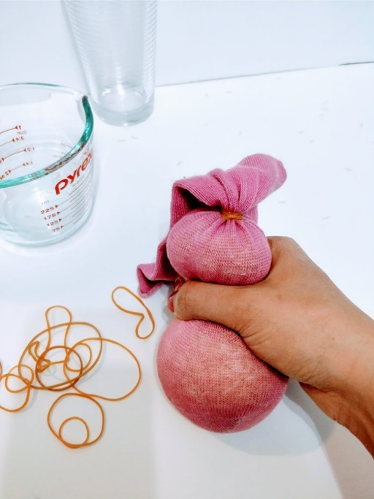
Step 5: Use another rubber band and make the bunny tail.
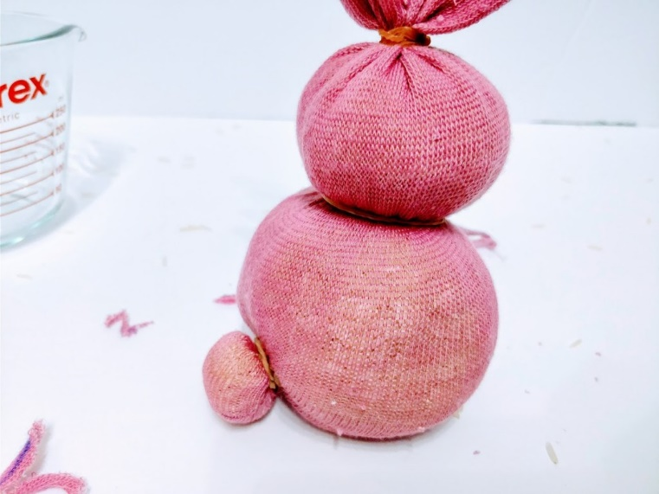

Step 6: To make the ears, cut any excess sock so that there is a couple of inches for the ears. If you want floppy ears that flop down, then leave them a bit longer.
Once the excess is gone, cut the top portion down the middle.
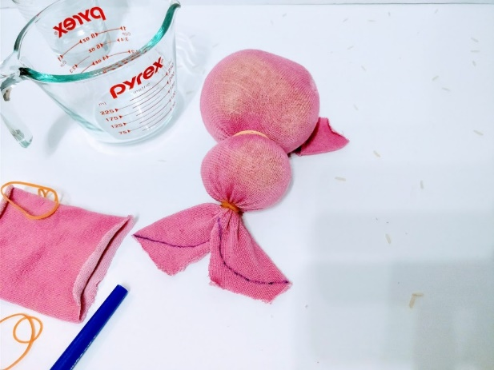
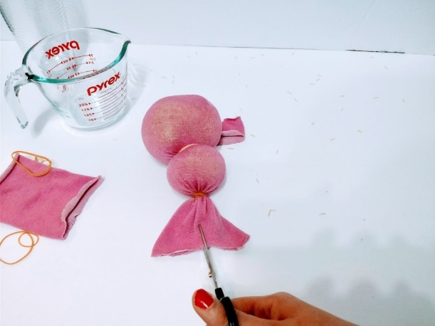
Using a marker, draw on a bunny ear shape. Take your scissors and cut along the marker line. Once done, your bunny ears should stand up straight (or flop down if you want floppy ears)
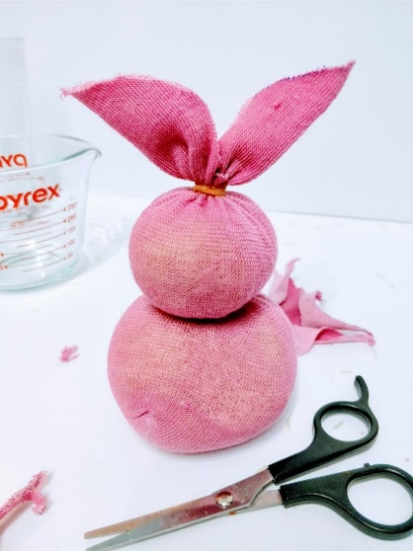
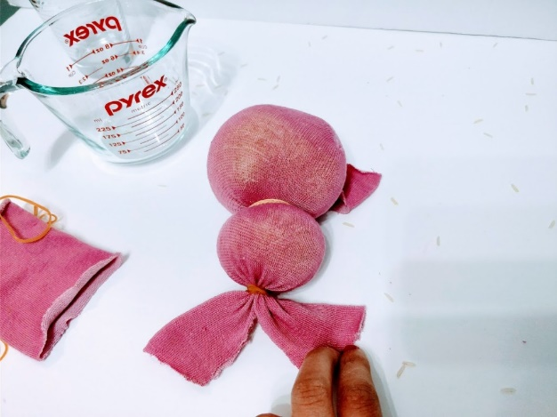
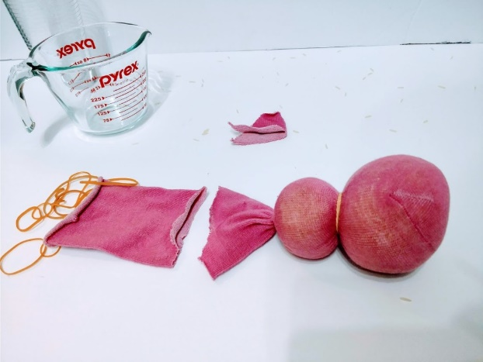

Step 7: Use the Sharpie to draw the bunny eyes and nose. To make the eyes, simply colour in two dots with the marker
To make the nose, draw an “x” shape. Super Easy!
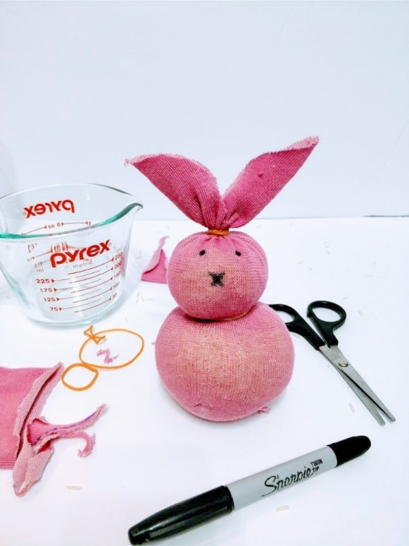

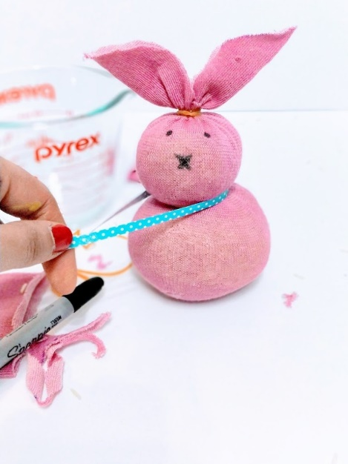
Step 8: This part is optional but it really adds a nice decorative touch to your bunny craft. Cut a long enough piece of ribbon and tie a bow around the bunnies neck. I used both fabric and plastic ribbon. They both worked well, but I like the look of the fabric ribbon a bite more. You can also use bakers twine, instead of ribbon if you have some lying around.

